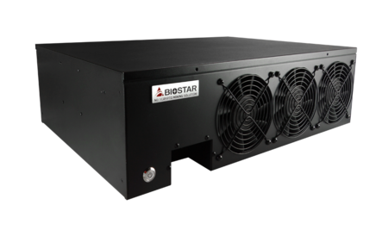 | iMiner A578X8D  - 8 AMD RX570 GPUs inside  - Plug and mine  - Blockchain grade hardware design  - Exclusive Mining Doctor software  - Supports major crypto currencies, such as ETH, ETC, XMR, and ZEC…etc.  - Supports win10 and ethOS mining OS  - ETH hash rate 220 MH/s (±5%)

Chipset
ACCESSORIES | - 1 x DVD Driver  - 1 x Quick Guide  - 1 x PSU  - 1 x POWER Cord

CPU-Chipset

Intel B250 chipset  Give your small business a boost with the Intel® B250 Chipset and the 7th Generation Intel® Core™ processor. The Intel B250 chipset provides you with the power and performance you need for your small business. | 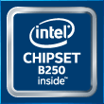

Video+

HDMI 4K2K  The new 4K2K resolution enables high-definition image display with four times the resolution of full HD, 4K2K display is faithfully express bright, highly detailed content that fills the entire screen with lifelike images. Connectivity with PCs via a single HDMI cable for displaying 4K2K data. | 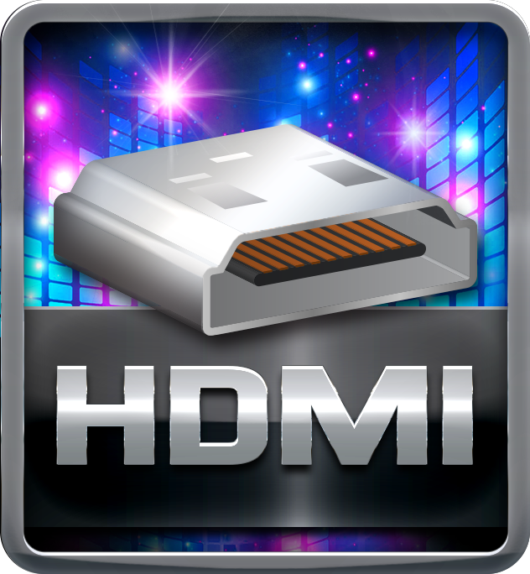
DX12  DirectX 12 introduces the next version of Direct3D, the graphics API at the heart of DirectX. Direct3D is one of the most critical pieces of a game or game engine, and we've redesigned it to be faster and more efficient than ever before. Direct3D 12 enables richer scenes, more objects, and full utilization of modern GPU hardware. | 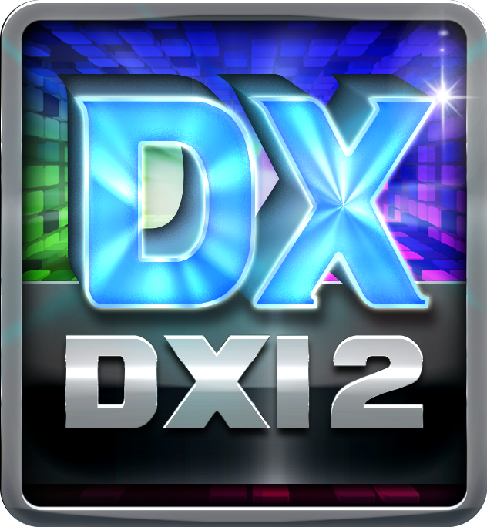

Speed+

USB 3.1 Gen 1 Type-A  Experience Fastest data transfers at 5 Gbps with USB 3.1 Gen 1--the new latest connectivity standard. Built to connect easily with next-generation components and peripherals, USB 3.1 Gen 1 transfers data 10X faster and backward compatible with previous USB 2.0 components. | 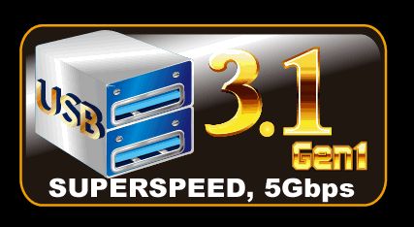
PCIe M.2 32Gb/s  PCI-e M.2 32Gb/s delivers the highest bandwidth and lower latency. It is 3 times faster compared with PCI-e M.2 10Gb/s. | 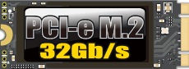
SATAIII 6Gbps  SATAIII 6Gbps provides a higher bandwidth to retrieve and transfer HD media. With this super speed data transfer, SATAIII allows an incredible data boost which is 2x faster than the SATA II. | 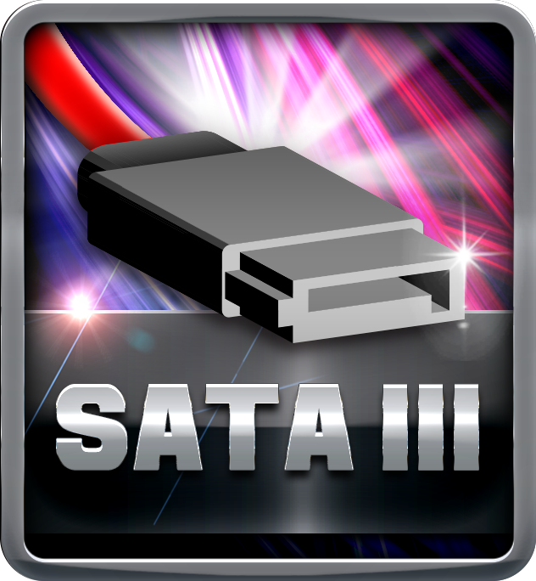

Protection+

ESD Protection  ESD (Electrostatic Discharge) is the major factor to destroy the PC by electrical overstress (EOS) condition. ESD occurred by PC users when touch any devices connect to a PC, which may result in damage to the motherboard or parts. ESD protection is designed to protect the motherboard and equipment from damage by EOS. | 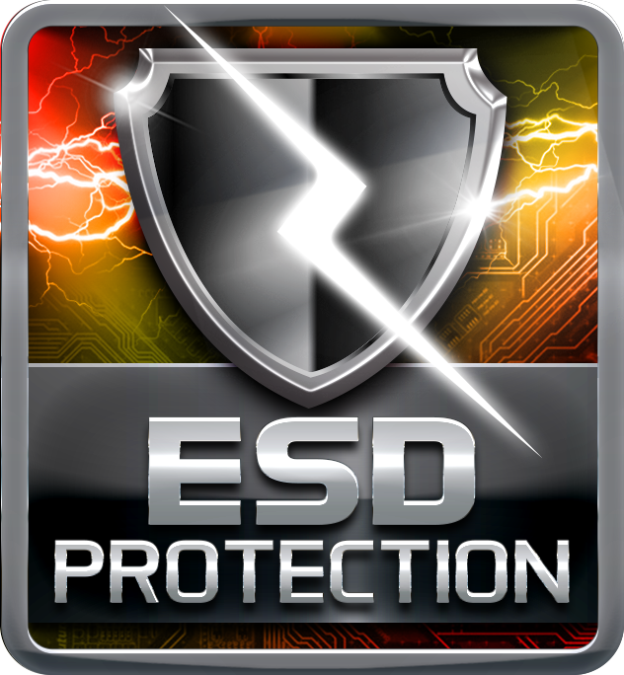
USB Polyswitch

On board dedicated power fuse to help prevent USB port failure. It prevents USB Port overcurrent and safe guard your system and device lifespan.
BIOS Virus Protection

When enabled, the BIOS will protect the boot sector and partition table by halting the system and flashing a warning message whether there's an attempt to write to these areas.
OC / OV / OH Protection

OC / OV / OH Protection design detects overvoltage conditions and prevents voltage surges from spreading in real time. It also actively cuts off the overvoltage supply to protect your system.
BullGuard Internet Security (90 days FREE trial)

BullGuard Internet Security comes with the broadest line-up of internet security features on the market, including: a cutting-edge dual Antivirus engine, Online Backup for your precious files, PC Tune Up to speed up your system, a Game Mode for a seamless gaming experience, Parental Control, Firewall, Safe Browsing and many more. Make the most of your digital life with Bullguard!

DIY+

BIOScreen Utility

Personalize your desktop with customizable boot logo. BIOScreen is the new feature that lets you personalize and create your own style with unique, custom-made boot logo.

