B360MY-Q7 V1.x

- Supports 9th & 8th Generation Intel® Core™ Processor
- Intel B360 single chip architecture
- Support 2-DIMM DDR4-1866/ 2133/ 2400/ 2666 up to 32G maximum capacity
- Support USB 3.1 Gen1
- Support GbE LAN

Chipset | - Intel B360
CPU SUPPORT | - 9th Gen Intel® Core™ i9 LGA 1151 Processor  - 9th Gen Intel® Core™ i5 LGA 1151 Processor  - 9th Gen Intel® Core™ i3 LGA 1151 Processor  - 8th Gen Intel® Core™ i7 LGA 1151 Processor  - 8th Gen Intel® Core™ i5 LGA 1151 Processor  - 8th Gen Intel® Core™ i3 LGA 1151 Processor  - 8th Gen Intel® Pentium® LGA 1151 Processor  - 8th Gen Intel® Celeron® LGA 1151 Processor  - Maximum CPU TDP (Thermal Design Power) : 91Watt
MEMORY | - Support Dual Channel DDR4 1866/2133/2400/2666 MHz  - 2 x DDR4 DIMM Memory Slot  - Max. Supports up to 32GB Memory  - Each DIMM supports non-ECC 4/8/16GB DDR4 module
INTEGRATED VIDEO | - By CPU model  - Supports DX12  - Supports HDCP
STORAGE | - 4 x SATA III Connectors
LAN | - Realtek RTL8111H - 10/100/1000Mb/s Controller  - Support Super LAN Surge Protection
AUDIO CODEC | - Realtek ALC887 8-Channel HD Audio
USB | - 6 x USB 3.1 Gen1 Port (4 on rear I/Os and 2 via internal headers)  - 4 x USB 2.0 Port(2 on rear I/Os and 2 via internal headers)
EXPANSION SLOT | - 1 x PCI-E 3.0 x16 Slot  - 2 x PCI-E 2.0 x1 Slot
REAR I/O | - 1 x PS/2 Mouse  - 1 x PS/2 Keyboard  - 4 x USB 3.1 Gen1 Ports  - 2 x USB 2.0 Port  - 1 x DVI-D Connector  - 1 x VGA Port  - 1 x LAN Port  - 3 x Audio Jacks
INTERNAL I/O | - 1 x USB 3.1 Gen1 Header (each header support 2 USB 3.1 Gen1 ports)  - 1 x USB 2.0 Header (each header supports 2 USB 2.0 ports)  - 4 x SATA III Connector (6Gb/s)  - 1 x Front Audio Header  - 1 x Front Panel Header  - 1 x CPU Fan Connector  - 1 x System Fan Connector  - 1 x 4-Pin Power Connector  - 1 x 24-Pin Power Connector  - 1 x Clear CMOS Header  - 1 x COM Port Header
H/W MONITORING | - CPU / System Temperature Monitoring  - CPU / System Fan Monitoring  - Smart / Manual CPU / System Fan Control  - System Voltage Monitoring
DIMENSION | - Micro ATX Form Factor Dimension: 22.6 cm x 17cm ( W x L )
OS SUPPORT | - Supports Windows 10(64bit) / 11(64bit)  - ※Biostar reserves the right to add or remove support for any OS with or without notice.
BUNDLE SOFTWARE | - BullGuard
ACCESSORIES | - 2 x SATA Cable  - 1 x I/O Shield  - 1 x DVD Driver  - 1 x Quick Guide

CPU-Chipset

Intel B360 chipset  Give your small business a boost with the Intel® B360 Chipset and the 8th Generation Intel® Core™ processor. The Intel B360 chipset provides you with the power and performance you need for your small business, entertainment and digital life. | 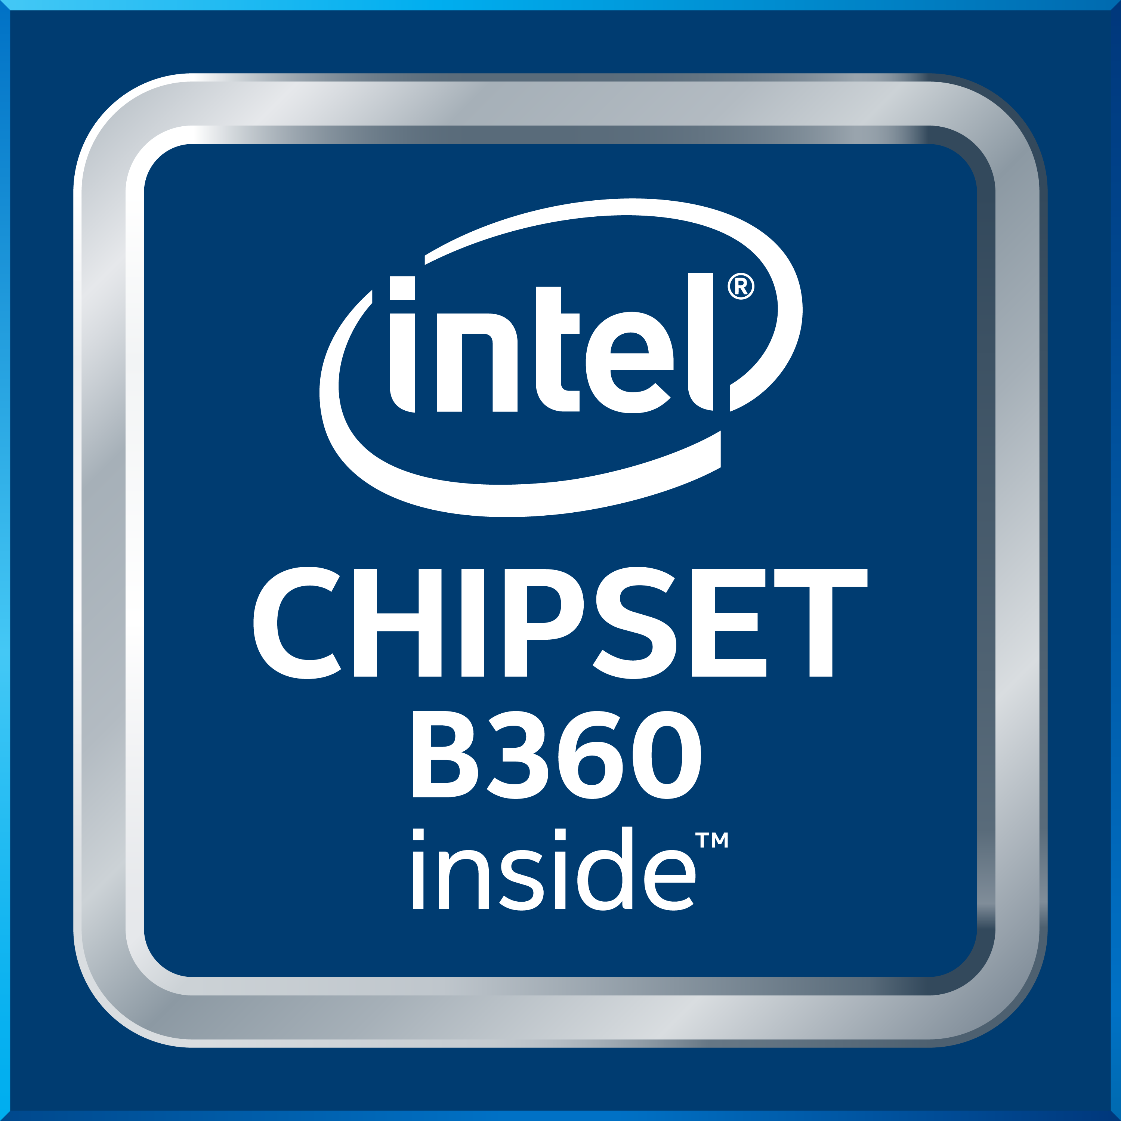

Audio+

HD Audio

Provides high quality sound with minimal loss of audio fidelity.

Video+

DVI  DVI is better than VGA for LCD displays since it is digital while VGA is analog. For LCD displays, the picture is digitized pixel per pixel. Through DVI, the panel gets data for each pixel, so the picture generated in the Graphics device matches the pixels on the panel itself. | 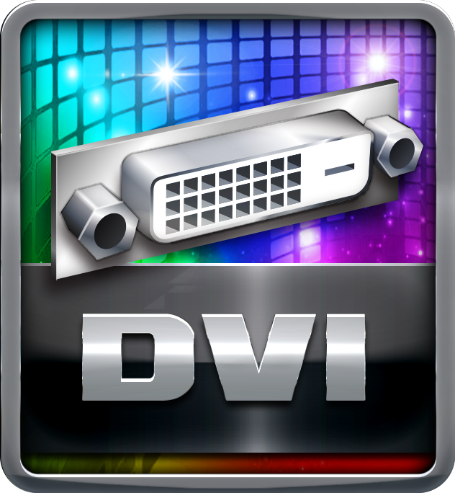
DX12  DirectX 12 introduces the next version of Direct3D, the graphics API at the heart of DirectX. Direct3D is one of the most critical pieces of a game or game engine, and we've redesigned it to be faster and more efficient than ever before. Direct3D 12 enables richer scenes, more objects, and full utilization of modern GPU hardware. | 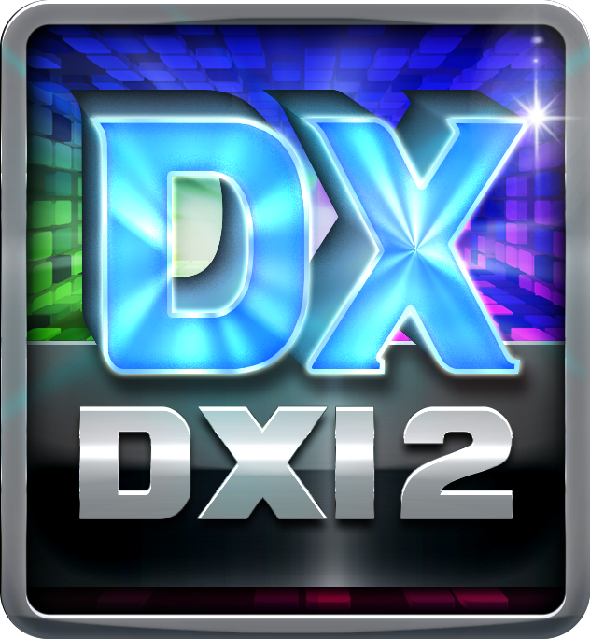

Speed+

USB 3.1 Gen 1 Type-A

Experience Fastest data transfers at 5 Gbps with USB 3.1 Gen 1--the new latest connectivity standard. Built to connect easily with next-generation components and peripherals, USB 3.1 Gen 1 transfers data 10X faster and backward compatible with previous USB 2.0 components.
SATAIII 6Gbps  SATAIII 6Gbps provides a higher bandwidth to retrieve and transfer HD media. With this super speed data transfer, SATAIII allows an incredible data boost which is 2x faster than the SATA II. | 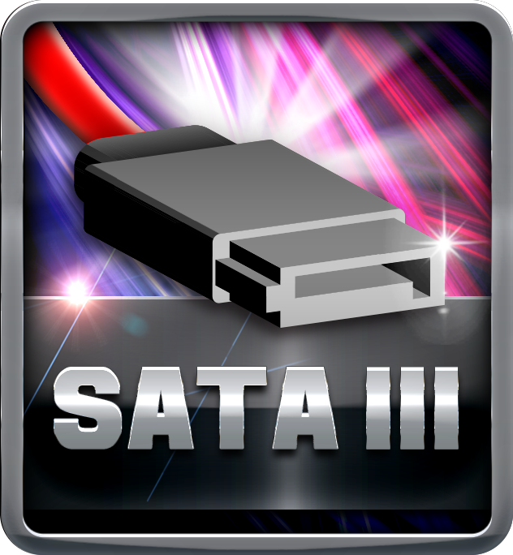
Dual DDR4  The primary advantages of DDR4 over DDR3, include higher module density, lower voltage requirements, coupled with higher data transfer rate. | 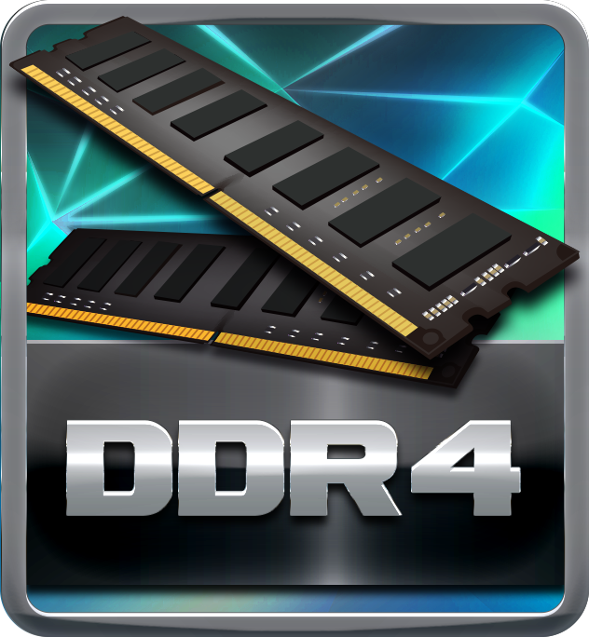

Durable+

100% Solid Caps

With armor-plated Biostar Technology, all capacitors are placed with 100% solid capacitors that have a lasting life cycle, durability and stability for crucial components.

Protection+

Super LAN Surge Protection  Super LAN Surge Protection, providing LAN port with more advanced antistatic protection capabilities by adding an integrated chip to strengthen electrical stability and prevent damage from lightning strikes and electrical surges. SLSP (Super LAN Surge Protection) series motherboard upgrades the existing system protection standards with maximum 4X protection comparing to other board makers. | 