IH81MC-Q3 V1.x

- Supports the Intel 4th generation Core i7 and Core i5 processors in the 1150 package
- Intel H81 single chip architecture
- Support Dual Channel DDR3 1600 MHz
- Support USB 3.1 Gen 1

Chipset | - Intel H81
CPU SUPPORT | - Intel® Core™ i7 LGA 1150 Processor  - Intel® Core™ i5 LGA 1150 Processor  - Intel® Core™ i3 LGA 1150 Processor  - Intel® Pentium® LGA 1150 Processor  - Intel® Celeron® LGA 1150 Processor  - Maximum CPU TDP (Thermal Design Power) : 95Watt
MEMORY | - Support Dual Channel DDR3 1600 MHz  - 2 x DDR3 DIMM Memory Slot
INTEGRATED VIDEO | - By CPU model  - Supports DX11.1
STORAGE | - 2 x SATA III Connector  - 2 x SATA II Connector
LAN | - Realtek RTL8106E - 10/100 Controller
AUDIO CODEC | - Realtek ALC662 6-Channel HD Audio
USB | - 2 x USB 3.1 Gen1 Port  - 6 x USB 2.0 Port (2 on rear I/Os and 4 via internal header)
EXPANSION SLOT | - 1 x PCI-E 3.0 x16 Slot  - 1 x PCI-E 2.0 x1 Slot
REAR I/O | - 1 x PS/2 Mouse  - 1 x PS/2 Keyboard  - 2 x USB 3.1 Gen1 Port  - 2 x USB 2.0 Port  - 1 x VGA Port  - 1 x LAN Port  - 3 x Audio Jacks
INTERNAL I/O | - 2 x USB 2.0 Header  - 2 x SATA III Connector (6Gb/s)  - 2 x SATA II Connector (3Gb/s )  - 1 x Front Audio Header  - 1 x Front Panel Header  - 1 x CPU Fan Connector  - 1 x 4-Pin Power Connector  - 1 x 24-Pin Power Connector  - 1 x Clear CMOS Header  - 1 x COM Port Header
DIMENSION | - Micro ATX Form Factor Dimension: 22.6cm x 17 cm ( W x L )
ACCESSORIES | - 2 x SATA Cable  - 1 x I/O Shield  - 1 x DVD Driver  - 1 x Quick Guide

CPU-Chipset

Intel H81 chipset  The latest Intel H81 Express chipset is a single-chipset design that supports socket LGA1150 4th generation Intel® Core™ i7/i5/i3/Pentium/Celeron processors. It natively supports up to two USB 3.0 ports for up to 10 times faster transfer rates than previous USB 2.0. Intel H81 Express chipset also supported iGPU such as Intel processors with DX11 graphics allow you enjoy the higher frame rate in Gaming experience. | 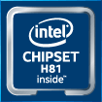

Audio+

HD Audio

Provides high quality sound with minimal loss of audio fidelity.

Video+

DX11.1

Direct3D 11.1 enables Direct3D 10 APIs and Direct3D 11 APIs to use one underlying rendering device. And it allows developers to achieve a high speed, fully conformant software rasterizer.

Speed+

USB 3.1 Gen 1 Type-A

Experience Fastest data transfers at 5 Gbps with USB 3.1 Gen 1--the new latest connectivity standard. Built to connect easily with next-generation components and peripherals, USB 3.1 Gen 1 transfers data 10X faster and backward compatible with previous USB 2.0 components.
PCIe 3.0  PCIe 3.0 is the ubiquitous and general-purpose PCI Express I/O standard. At 8GT/s bit rate, the interconnect performance bandwidth is doubled over PCIe 2.0, while preserving compatibility with software and mechanical interfaces. | 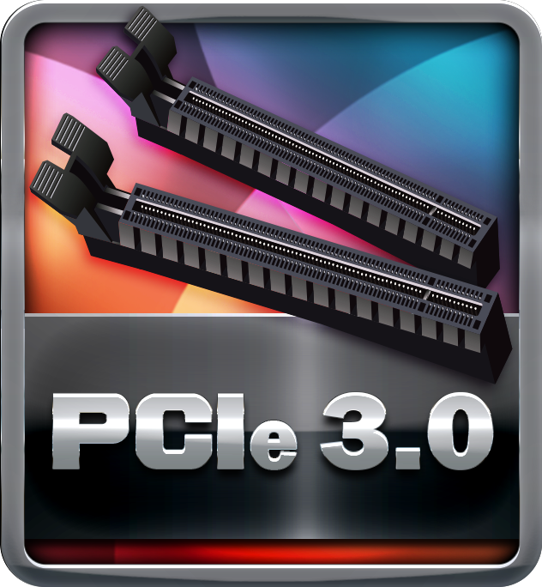
SATAIII 6Gbps  SATAIII 6Gbps provides a higher bandwidth to retrieve and transfer HD media. With this super speed data transfer, SATAIII allows an incredible data boost which is 2x faster than the SATA II. | 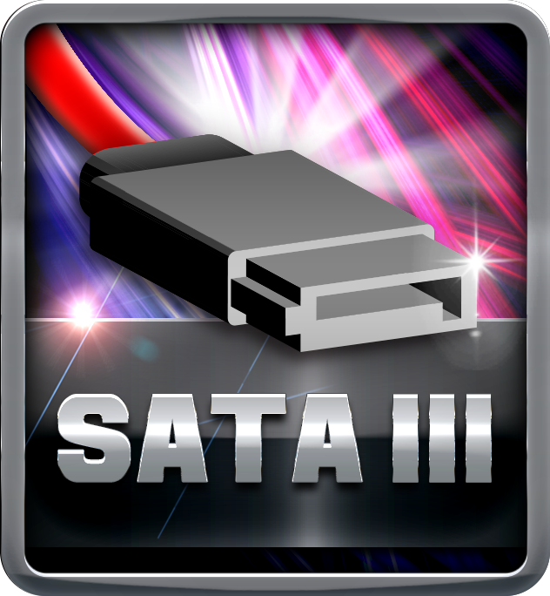
Dual DDR3-1600

It supports 2 or 4 DIMM Slots DDR3 memory that features data transfer rates of DDR3 1600/1333. The processor support 2 memory channels and setting the memory multiplier, allows selection of the channel speed. These clearly uplift the band width and boost the overall system performance.

