H110MV-Q7 V1.x

- Supports 6th & 7th Generation Intel® Core™ Processor
- Intel H110 single chip architecture
- Support Dual Channel DDR4 2133/1866 MHz
- Support GbE LAN
- Support Super LAN Surge Protection

Chipset | - Intel H110
CPU SUPPORT | - 7th & 6th Gen Intel® Core™ i7 LGA 1151 Processor  - 7th & 6th Gen Intel® Core™ i5 LGA 1151 Processor  - 7th & 6th Gen Intel® Core™ i3 LGA 1151 Processor  - 7th & 6th Gen Intel® Pentium® LGA 1151 Processor  - 7th & 6th Gen Intel® Celeron® LGA 1151 Processor  - Maximum CPU TDP (Thermal Design Power) : 95Watt
MEMORY | - Support Dual Channel DDR4 2133/1866 MHz  - 2 x DDR4 DIMM Memory Slot
INTEGRATED VIDEO | - By CPU model  - Supports DX12  - Supports HDCP
STORAGE | - 4 x SATA III Connector
LAN | - Realtek RTL8111H - 10/100/1000Mb/s Controller  - Support Super LAN Surge Protection
AUDIO CODEC | - Realtek ALC887 8-Channel HD Audio  - Support HD Audio
USB | - 4 x USB 3.1 Gen1 Port (2 on rear I/Os and 2 via internal header)  - 6 x USB 2.0 Port (2 on rear I/Os and 4 via internal header)
EXPANSION SLOT | - 1 x PCI-E 3.0 x16 Slot  - 2 x PCI-E 2.0 x1 Slot
REAR I/O | - 1 x PS/2  - 1 x PS/2 Mouse  - 2 x USB 3.1 Gen1 Port  - 2 x USB 3.0 Port  - 2 x USB 2.0 Port  - 1 x COM Port  - 1 x VGA Port  - 1 x LAN Port  - 3 x Audio Jacks
INTERNAL I/O | - 1 x USB 3.1 Gen1 Header  - 2 x USB 2.0 Header  - 4 x SATA III Connector (6Gb/s)  - 1 x Front Audio Header  - 1 x Front Panel Header  - 1 x CPU Fan Connector  - 1 x System Fan Connector  - 1 x 4-Pin Power Connector  - 1 x 24-Pin Power Connector  - 1 x COM Port Header
DIMENSION | - Micro ATX Form Factor Dimension: 22.6 cm x 17 cm ( W x L )
ACCESSORIES | - 2 x SATA Cable  - 1 x I/O Shield  - 1 x DVD Driver  - 1 x Quick Guide

CPU-Chipset

Intel H110 chipset  The Intel® H110 chipset is a single-chipset design to support socket 1151 Intel® 6th generation Intel® Core™ processor-based platform. Provides excellent performance and increased bandwidth and stability. Intel® H110 chipset can also enable iGPU function, letting users enjoy the latest Intel® integrated graphic performance. The PC platform features improved adaptive performance that adds speed when you need it. When combined with advanced system responsiveness, the platform delivers the ultimate PC experience. | 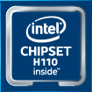

Audio+

HD Audio

Provides high quality sound with minimal loss of audio fidelity.

Speed+

USB 3.1 Gen 1 Type-A  Experience Fastest data transfers at 5 Gbps with USB 3.1 Gen 1--the new latest connectivity standard. Built to connect easily with next-generation components and peripherals, USB 3.1 Gen 1 transfers data 10X faster and backward compatible with previous USB 2.0 components. | 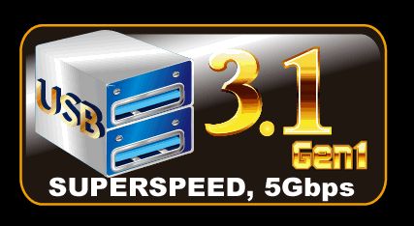
PCIe 3.0  PCIe 3.0 is the ubiquitous and general-purpose PCI Express I/O standard. At 8GT/s bit rate, the interconnect performance bandwidth is doubled over PCIe 2.0, while preserving compatibility with software and mechanical interfaces. | 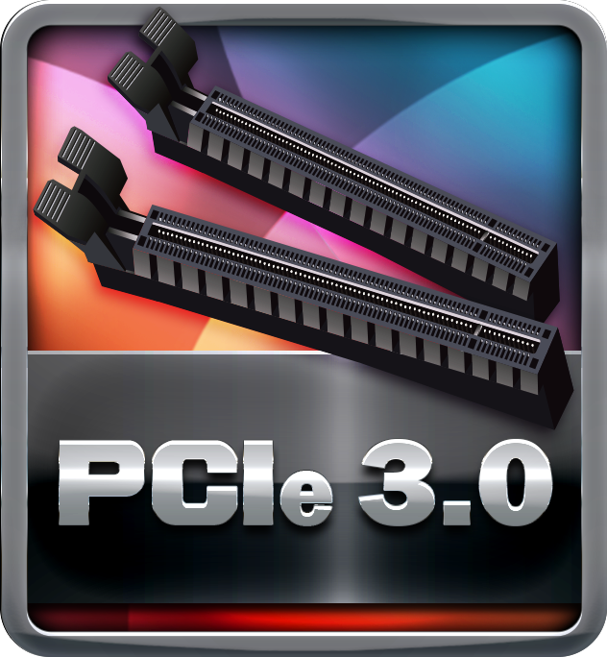
SATAIII 6Gbps  SATAIII 6Gbps provides a higher bandwidth to retrieve and transfer HD media. With this super speed data transfer, SATAIII allows an incredible data boost which is 2x faster than the SATA II. | 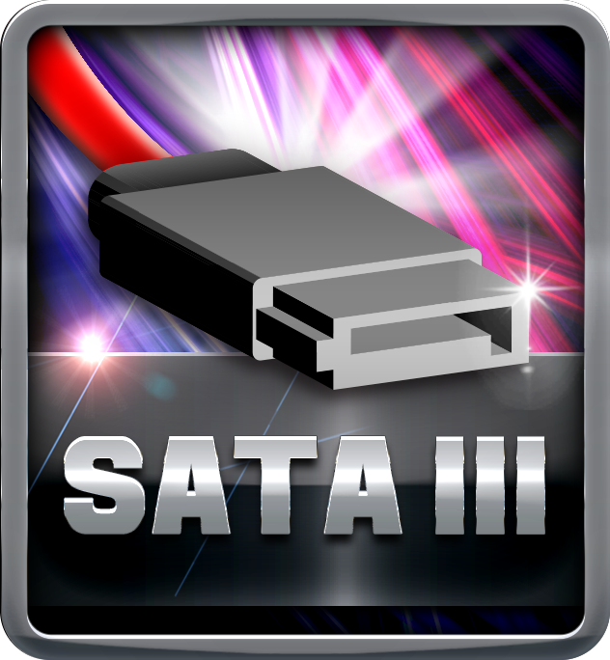
Dual DDR4  The primary advantages of DDR4 over DDR3, include higher module density, lower voltage requirements, coupled with higher data transfer rate. | 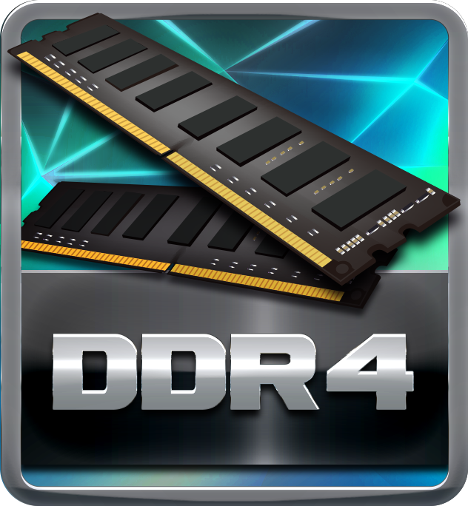

Durable+

100% Solid Caps

With armor-plated Biostar Technology, all capacitors are placed with 100% solid capacitors that have a lasting life cycle, durability and stability for crucial components.

Protection+

Super LAN Surge Protection  Super LAN Surge Protection, providing LAN port with more advanced antistatic protection capabilities by adding an integrated chip to strengthen electrical stability and prevent damage from lightning strikes and electrical surges. SLSP (Super LAN Surge Protection) series motherboard upgrades the existing system protection standards with maximum 4X protection comparing to other board makers. | 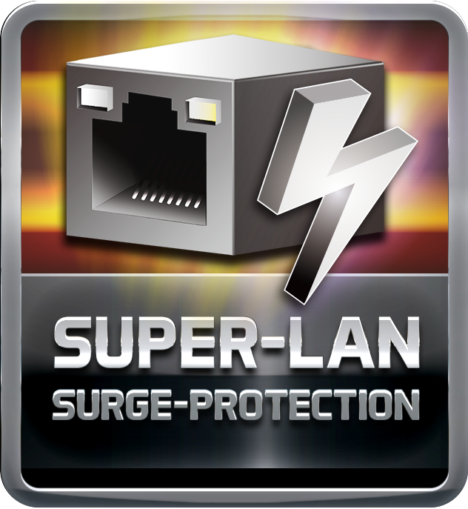

DIY+

UEFI BIOS

Unified Extensible Firmware Interface (UEFI) is a brand new framework that provides a revolutionary interface. It is a modern clear and easy-to-use graphical user interface. The UEFI comes with a colorful easy-understand icons leads users into the setup layer directly.

