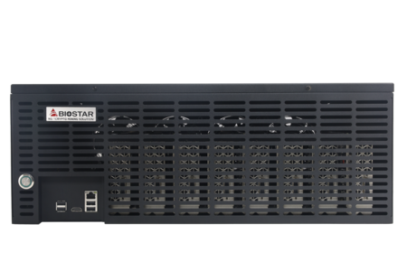 | iMiner A588X8D2  - 8 AMD RX580 GPUs inside  - Plug and mine  - Blockchain grade hardware design  - Supports major crypto currencies, such as ETH, ETC, RVN, and ERG…etc.  - Supports Win10,HiveOS and Linux  - ETH hash rate 232 MH/s (±5%)

Motherboard | - TB360-BTC D+
CPU | - Intel G4900
Memory | - So-Dimm 8G DDR4 2666
SSD | - SSD 120G
GPU | - 8 x AMD RX580 8G 2048SP
PSU | - 2000W / 220V ( Only supports 220V )
Rear Panel | - 4 x USB 2.0 Port  - 1 x HDMI Connector  - 1 x RJ-45 Port
LAN | - Realtek RTL8111H - 10/100/1000 Controller
OS SUPPORT | - Windows 10(64bit)  - Linux OS(64bits)  - HiveOS
ACCESSORIES | - 1 x DVD Driver  - 1 x POWER Cord
Hashrate | - ETH : 232 MH/s (±5%)
Chassis | - Black / 4 x 12 cm FAN
Chassis Dimension | - 54 x 42 x 20 cm ( L x W x H )
Carton Dimension | - 62 x 51.5 x 29 cm ( L x W x H )
Net weight | - 15.0 kg
Gross weight | - 16.6 kg
Crypto Currency support | - ETH, ETC, RVN, ERG

