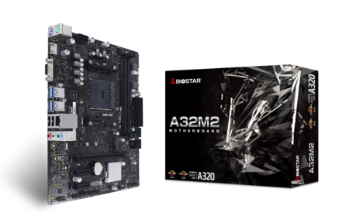 | A32M2 6.0  - Support AMD Ryzen CPU / APU  - AMD A320 single chip architecture  - Support 2-DIMM DDR4-1866/ 2133/ 2400/ 2666/ 2933/ 3200(OC) up to 32G maximum capacity  - Support HDMI  - Support USB 3.2 Gen1  - Support GbE LAN

Chipset | - AMD A320
CPU SUPPORT | - Supports AMD AM4 Socket for 3rd, 2nd and 1st Gen Ryzen/2nd and 1st Gen Ryzen with Radeon Vega  - Graphics/Athlon with Radeon Vega Graphics/7th Gen A-Series/Athlon X4 Processors
MEMORY | - Supports Dual Channel DDR4 1866/ 2133/ 2400/ 2666/ 2933/ 3200(OC)  - 2 x DDR4 DIMM Memory Slots, Max. Supports up to 32 GB Memory  - Each DIMM supports non-ECC 8/16 GB DDR4 module  - * Please refer to www.biostar.com.tw for Memory support list.
INTEGRATED VIDEO | - By CPU model  - Supports DX12  - Supports HDCP
STORAGE | - 4 x SATA III Connectors (6Gb/s) : Supports AHCI & RAID 0, 1, 10  - 1 x M.2 (M Key) Socket:  - Supports M.2 Type 2242/ 2260/ 2280 SSD module  - Supports PCI-E 3.0 x 4 (32Gb/s) - NVMe/ AHCI SSD & SATA III (6.0Gb/s) SSD  - (Ryzen series - Summit  - Ridge / Pinnacle Ridge / Raven Ridge)  - Supports SATA III (6.0Gb/s) SSD (A-series APU - Bristol Ridge)
LAN | - Realtek RTL 8111H  - 10/ 100/ 1000 Mb/s auto negotiation, Half / Full duplex capability
AUDIO CODEC | - Realtek ALC887  - 7.1 Channels, High Definition Audio
USB | - 4 x USB 3.2 (Gen1) port (4 on rear I/Os)  - 6 x USB 2.0 port (2 on rear I/Os and 4 via internal headers)
EXPANSION SLOT | - 2 x PCIe 2.0 x1 Slots  - 1 x PCIe 3.0 x16 Slot (The bandwidth is depended on CPU)
REAR I/O | - 1 x PS/2 Mouse  - 1 x PS/2 Keyboard  - 1 x HDMI Port  - 1 x VGA Port  - 1 x LAN port  - 4 x USB 3.2 (Gen1) Ports  - 2 x USB 2.0 Ports  - 3 x Audio Jack
INTERNAL I/O | - 4 x SATA III 6.0Gb/s Connectors  - 2 x USB 2.0 Header (each header supports 2 USB 2.0 ports)  - 1 x 8-Pin Power Connector  - 1 x 24-Pin Power Connector  - 1 x CPU Fan Connector  - 1 x System Fan Connector  - 1 x Front Panel Header  - 1 x Front Audio Header  - 1 x COM Port Header  - 1 x Clear CMOS Header
H/W MONITORING | - CPU / System Temperature Monitoring  - CPU / System Fan Monitoring  - Smart / Manual CPU Fan Control  - CPU/DDR Voltage Monitoring
DIMENSION | - Micro ATX Form Factor Dimension: 19.8cm x 24.4cm ( W x L )
OS SUPPORT | - Supports Windows 7(64bit) / 10(64bit)  - ※Biostar reserves the right to add or remove support for any OS with or without notice.
BUNDLE SOFTWARE | - BullGuard
ACCESSORIES | - 2 x SATA Cable  - 1 x I/O Shield  - 1 x DVD Driver  - 1 x Quick Guide
FEATURES | - Supports 100% Solid capacitor

CPU-Chipset

AMD A320 chipset

AMD's A320 chipset provides a simple, stable platform and more than enough connectivity and bandwidth ​options to satisfy both demanding home users and media aficionados.

Audio+

HD Audio

Provides high quality sound with minimal loss of audio fidelity.
Hi-Fi Ground  BIOSTAR Hi-Fi Ground ( Golden Line ) is noise-blocking multi-layer PCB design to isolates analog audio signals from digital sources. Unique PCB layout is ideal for exceptional clarity and high fidelity sound. | 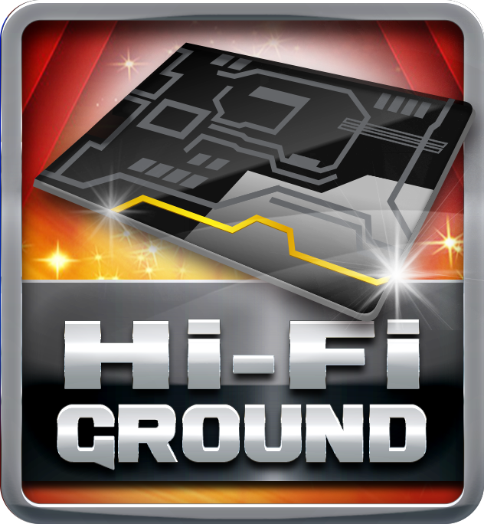

Video+

HDMI 4K2K  The new 4K2K resolution enables high-definition image display with four times the resolution of full HD, 4K2K display is faithfully express bright, highly detailed content that fills the entire screen with lifelike images. Connectivity with PCs via a single HDMI cable for displaying 4K2K data. | 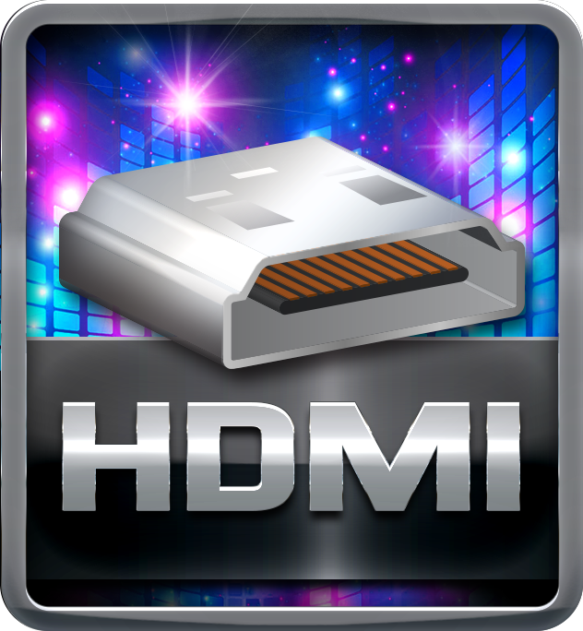
DX12  DirectX 12 introduces the next version of Direct3D, the graphics API at the heart of DirectX. Direct3D is one of the most critical pieces of a game or game engine, and we've redesigned it to be faster and more efficient than ever before. Direct3D 12 enables richer scenes, more objects, and full utilization of modern GPU hardware. | 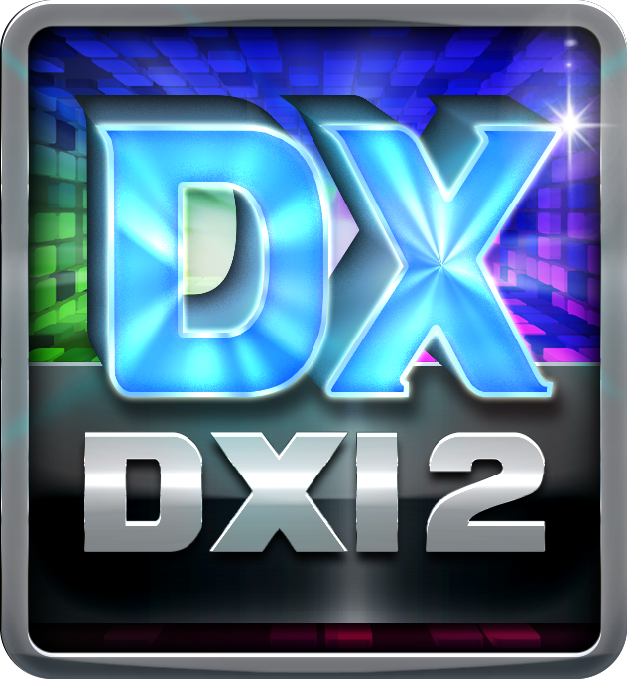

Speed+

PCIe M.2  PCIe M.2 32Gb/s delivers the highest bandwidth and lower latency. It is 3 times faster compared with PCIe M.2 10Gb/s. | 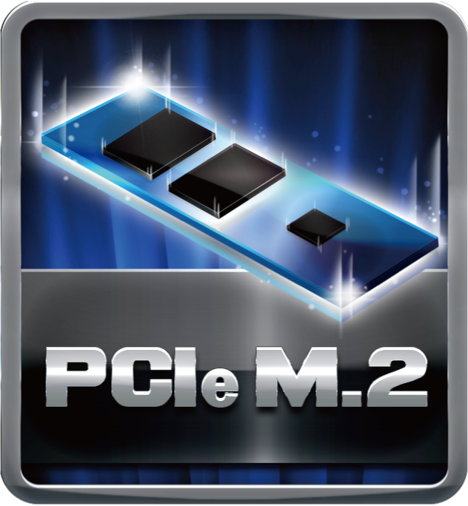
SATAIII 6Gbps  SATAIII 6Gbps provides a higher bandwidth to retrieve and transfer HD media. With this super speed data transfer, SATAIII allows an incredible data boost which is 2x faster than the SATA II. | 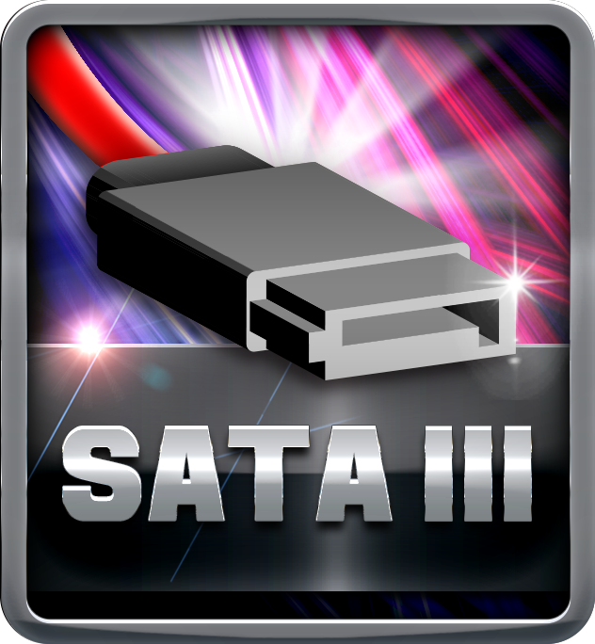
Dual DDR4  The primary advantages of DDR4 over DDR3, include higher module density, lower voltage requirements, coupled with higher data transfer rate. | 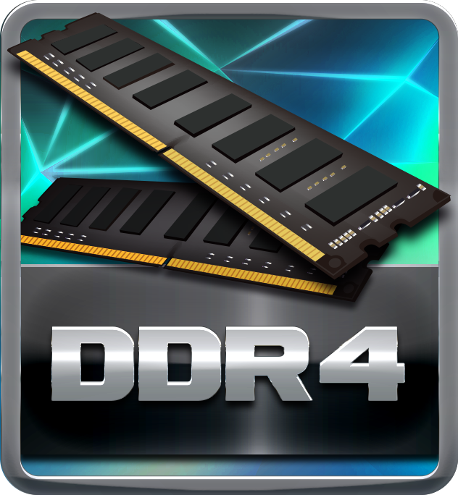
USB 3.2 Gen1 Type-A  USB 3.2 Gen1 delivers a compelling performance boosts and can be used to connect multiple devices without worrying about compatibility. It is capable of data transfer speeds up to 5Gbps and backwards compatible with all existing USB products. | 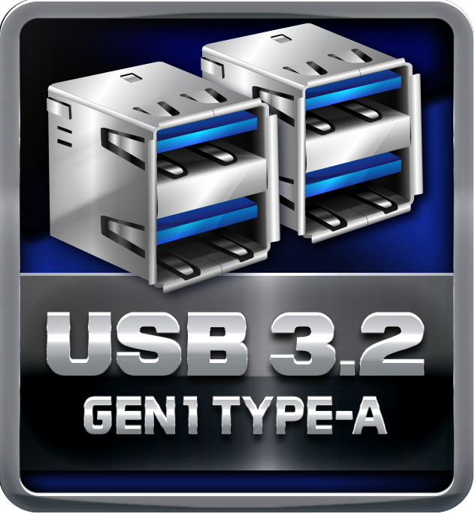

Durable+

100% Solid Caps

With armor-plated Biostar Technology, all capacitors are placed with 100% solid capacitors that have a lasting life cycle, durability and stability for crucial components.

Protection+

Super LAN Surge Protection

Super LAN Surge Protection, providing LAN port with more advanced antistatic protection capabilities by adding an integrated chip to strengthen electrical stability and prevent damage from lightning strikes and electrical surges. SLSP (Super LAN Surge Protection) series motherboard upgrades the existing system protection standards with maximum 4X protection comparing to other board makers.
BullGuard Internet Security (90 days FREE trial)

BullGuard Internet Security comes with the broadest line-up of internet security features on the market, including: a cutting-edge dual Antivirus engine, Online Backup for your precious files, PC Tune Up to speed up your system, a Game Mode for a seamless gaming experience, Parental Control, Firewall, Safe Browsing and many more. Make the most of your digital life with Bullguard!

DIY+

UEFI BIOS

Unified Extensible Firmware Interface (UEFI) is a brand new framework that provides a revolutionary interface. It is a modern clear and easy-to-use graphical user interface. The UEFI comes with a colorful easy-understand icons leads users into the setup layer directly.
BIO-Flasher

BIO-Flasher is a convenient BIOS update tool. Just launch this tool and put the BIOS on USB pen driver before entering the OS. You can update your BIOS with only a few clicks without preparing an additional floppy disk or other complicated flash utility.
A.I FAN

With A.I FAN users can ensure that their gaming PC can maintain its performance while staying cool. According to different cooling needs and usage scenarios, users can control speed modes. Allows users to have more customizability of fan modes and automatically detects different temperatures to make fan operate at defined speed for optimal cooling performance. Furthermore, A.I FAN support both PWM and DC voltage fans for more cooling options.
HDMI

The terms HDMI and HDMI High-Definition Multimedia Interface, and the HDMI Logo are trademarks or registered trademarks of HDMI Licensing Administrator, Inc. in the United States and other countries.

