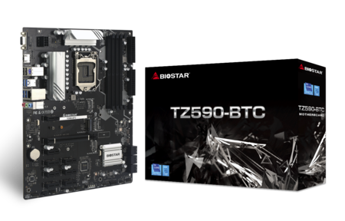 | TZ590-BTC 6.0  - Supports 10th/ 11th Generation Intel Core™ Processor  - Intel Z590 single chip architecture  - Support 4-DIMM DDR4-3600(OC)/ 3200/ 2933/ 2800/ 2666/ 2400/ 2133 up to 128G maximum capacity  - Support 8 x PCIe 3.0 slots  - Support 1 x PCIe 4.0 x16 Slot (x8 mode) (11th CPU Only)  - Support HDMI Connector

Chipset | - Intel Z590
CPU SUPPORT | - Support for 10th/ 11th Generation Intel Core™ i9/ i7/ i5/ i3 processors and Intel Pentium processors/  - Intel Celeron processors in the LGA1200 package  - * Please refer to www.biostar.com.tw for CPU support list.
MEMORY | - Supports Dual Channel DDR4 3600(OC)/ 3200/ 2933/ 2800/ 2666/ 2400/ 2133  - 4 x DDR4 DIMM Memory Slot, Max. Supports up to 128 GB Memory  - Each DIMM supports non-ECC 4/8/16/32GB DDR4 module  - Support Intel Extreme Memory Profile (XMP) memory modules  - * Please refer to www.biostar.com.tw for Memory support list.
INTEGRATED VIDEO | - By CPU model  - Supports DX12  - Supports HDCP
STORAGE | - -- Total supports 1x M.2 socket and 6x SATA III (6Gb/s) ports  - 6 x SATA III Connector (6Gb/s)  - 1 x M.2 (M Key) Socket:  - (M Key) Socket (M2_PCIEG4_64G_2)  - Supports PCIE Gen4 11th Generation Intel Core™ only  - Supports M.2 Type 2280 SSD module  - Supports PCI-E 4.0 x 4 (64Gb/s)  - Supports Intel Rapid Storage Technology and Intel Optane Technology
LAN | - Intel I219V  - 10/ 100/ 1000 Mb/s auto negotiation, Half / Full duplex capability
AUDIO CODEC | - ALC887  - 7.1 Channels, High Definition Audio
USB | - 6 x USB 3.2 (Gen1) ports (4 on rear I/Os and 2 via internal header)  - 6 x USB 2.0 ports (2 on rear I/Os and 4 via internal header)
EXPANSION SLOT | - 8 x PCIe 3.0 x1 Slots  - 1 x PCIe 4.0 x16 Slot (x8 mode) (Supports PCIE Gen4 11th Generation Intel Core™ only)
REAR I/O | - 1 x PS/2 Keyboard/Mouse Port  - 1 x HDMI Port  - 1 x VGA Port  - 4 x USB 3.2 (Gen1) Ports  - 2 x USB 2.0 Ports  - 1 x LAN port  - 3 x Audio Jack
INTERNAL I/O | - 6 x SATA III Connectors (6Gb/s)  - 2 x USB 2.0 Headers (each header supports 2 USB 2.0 ports)  - 1 x 8-Pin Power Connector  - 2 x 24-Pin Power Connectors  - 1 x CPU Fan Connector  - 1 x CPU water cooling connector (CPU_OPT)  - 1 x System Fan Connector  - 1 x Front Panel Header  - 1 x Front Audio Header  - 1 x Internal Stereo Speaker Header  - 1 x Clear CMOS Header  - 1 x COM Port Header  - 1 x TPM Header
H/W MONITORING | - CPU / System Temperature Monitoring  - CPU / System Fan Monitoring  - System Fan Monitoring  - Smart / Manual CPU Fan Control  - System Voltage Monitoring
DIMENSION | - ATX Form Factor Dimension: 30.5cm x 24.4cm ( W x L )
OS SUPPORT | - Supports Windows 10(64bit) / 11(64bit)  - ※Biostar reserves the right to add or remove support for any OS with or without notice.
BUNDLE SOFTWARE | - BullGuard
ACCESSORIES | - 2 x SATA Cable  - 1 x I/O Shield  - 1 x DVD Driver  - 1 x User Manual
FEATURES | - BIO-FLASHER  - A.I FAN  - PCI-E Slot Detection BIOS Boot Screen  - PCIe M.2 4.0

CPU-Chipset

Intel Z590 chipset  With the Intel® Z590 chipset and the 10th/ 11th generation Intel® Core™ i9/ i7/ i5/ i3 processors and Intel® Pentium® processors, you will immediately be at the forefront of the battlefield, fueled by mind-blowing power and performance. From content creation to gaming, the Intel Z590 chipset provides you with the power and performance you need. | 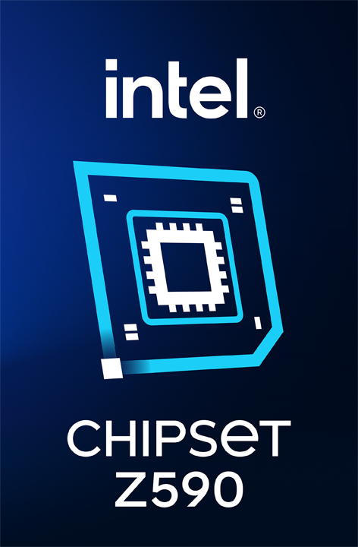

Audio+

HD Audio

Provides high quality sound with minimal loss of audio fidelity.

Video+

HDMI 4K2K  The new 4K2K resolution enables high-definition image display with four times the resolution of full HD, 4K2K display is faithfully express bright, highly detailed content that fills the entire screen with lifelike images. Connectivity with PCs via a single HDMI cable for displaying 4K2K data. | 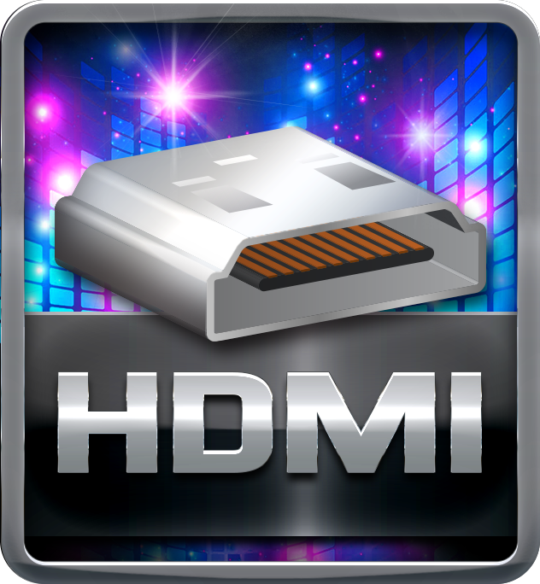
DX12  DirectX 12 introduces the next version of Direct3D, the graphics API at the heart of DirectX. Direct3D is one of the most critical pieces of a game or game engine, and we've redesigned it to be faster and more efficient than ever before. Direct3D 12 enables richer scenes, more objects, and full utilization of modern GPU hardware. | 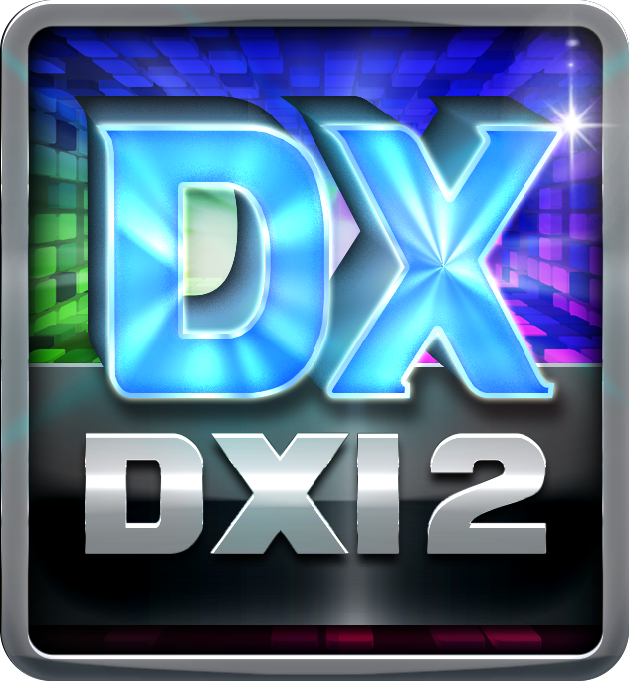
Integrated HDMI with HDCP

Onboard HDMI connector allows full video & audio support. It has industry-leading high definition video quality.

Speed+

Intel GbE LAN  Unlike ordinary LAN solution, Intel® GbE LAN offers fewer CPU resource consumption and more bandwidth stability. Thus, Intel® LAN is the best choice for performance seekers. | 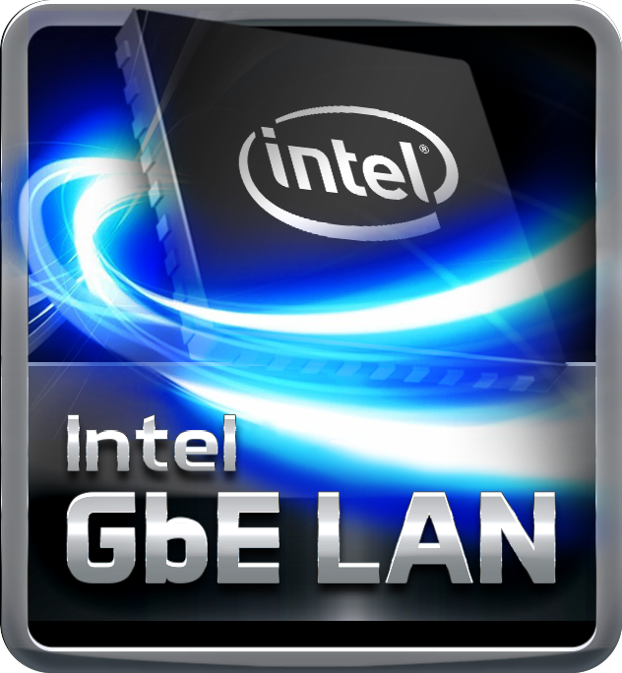
PCIe M.2  PCIe M.2 32Gb/s delivers the highest bandwidth and lower latency. It is 3 times faster compared with PCIe M.2 10Gb/s. | 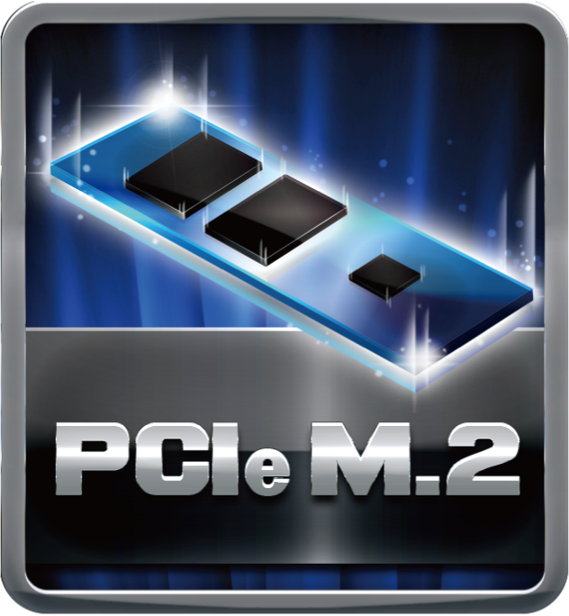
PCIe 3.0  PCIe 3.0 is the ubiquitous and general-purpose PCI Express I/O standard. At 8GT/s bit rate, the interconnect performance bandwidth is doubled over PCIe 2.0, while preserving compatibility with software and mechanical interfaces. | 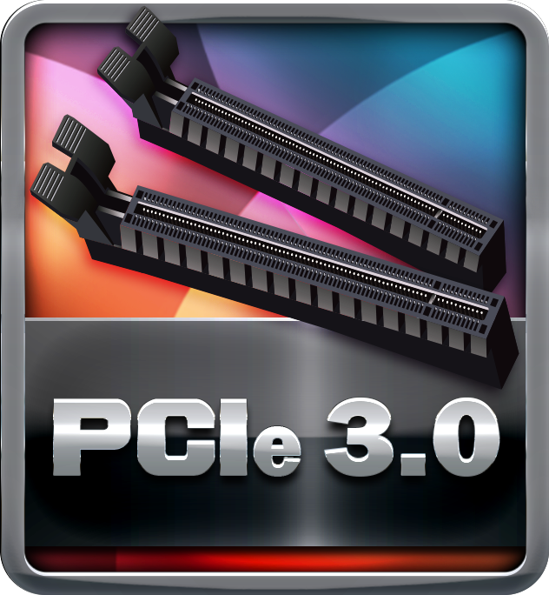
SATAIII 6Gbps  SATAIII 6Gbps provides a higher bandwidth to retrieve and transfer HD media. With this super speed data transfer, SATAIII allows an incredible data boost which is 2x faster than the SATA II. | 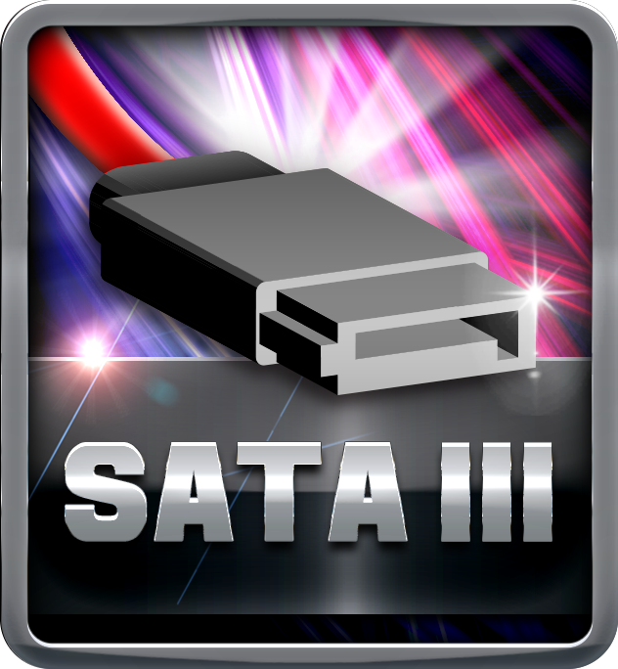
Dual DDR4  The primary advantages of DDR4 over DDR3, include higher module density, lower voltage requirements, coupled with higher data transfer rate. | 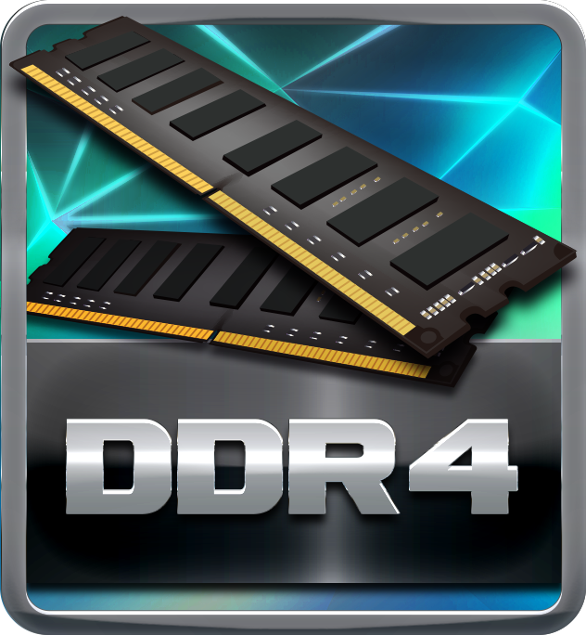
PCIe 4.0  PCIe 4.0 is the ubiquitous and general-purpose PCI Express I/O standard. At 16GT/s bit rate, the interconnect performance bandwidth is doubled over PCIe 3.0, while preserving compatibility with software and mechanical interfaces. | 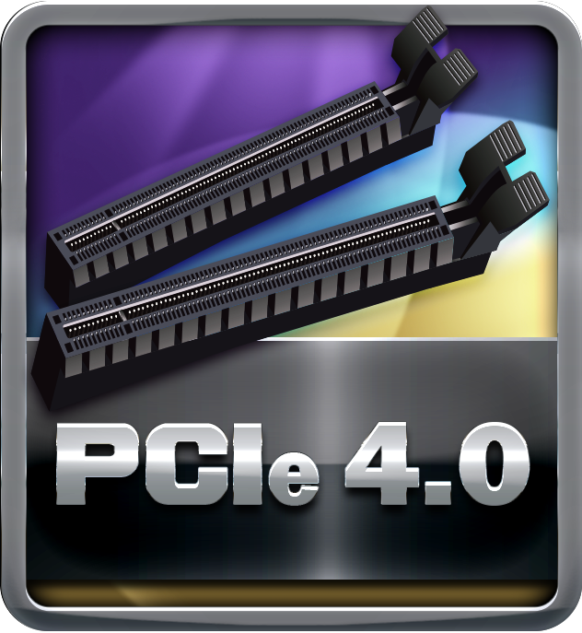
PCIe 4.0 M.2  PCIe 4.0 M.2 delivers the highest bandwidth and lower latency. It is 2 times faster compared with PCIe 3.0 M.2 . | 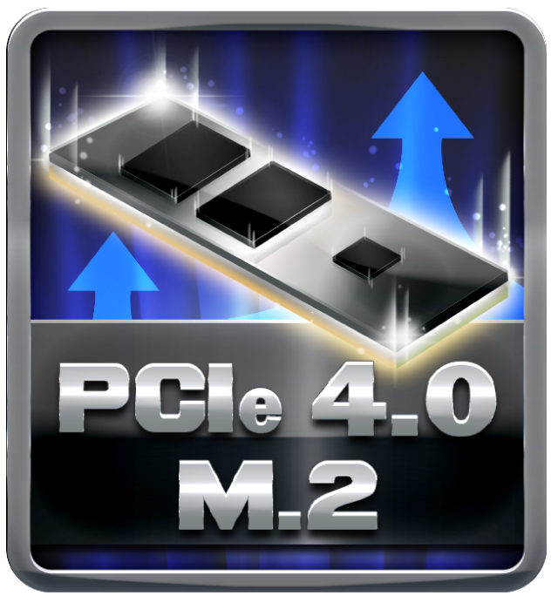
USB 3.2 Gen1 Type-A  USB 3.2 Gen1 delivers a compelling performance boosts and can be used to connect multiple devices without worrying about compatibility. It is capable of data transfer speeds up to 5Gbps and backwards compatible with all existing USB products. | 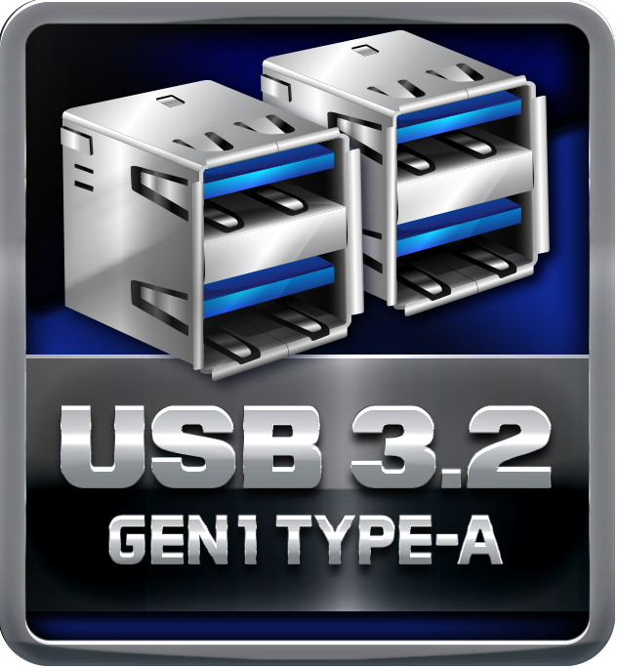
Digital PWM  Digital PWM controller is with dual-output multiphase that faster transient performance and accurately regulated frequency control. It can be enabled to greatly increase system efficiency. | 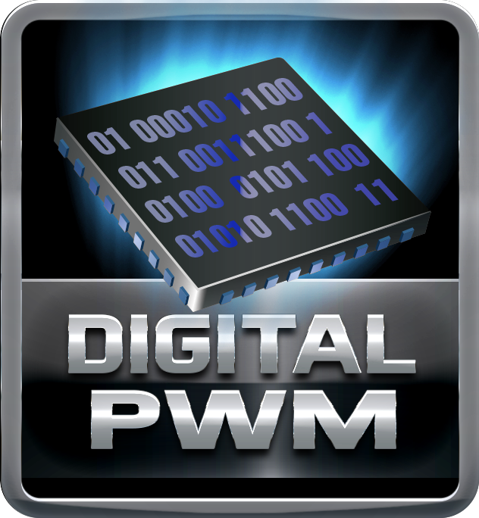

Durable+

Moistureproof of PCB

The popularity of PC usage and working environment is getting deteriorating and moist (rural, coastal, etc.). The PCB will be oxidizing easily by damp or absorbed moisture, and ionic migration or CAF (Conductive Anodic Filament) will be generated. Moisture-proof PCB meets high density and high reliability requirements for moisture proof.
Low RdsOn P-Pak MOS

Low resistance design can significantly reduce the current out of energy loss.
Low temperature, small size, excellent thermal conductivity.

Protection+

Super Anti-Surge Protection

BIOSTAR exclusive Anti-Surge design provides the best protection of board and extends the product life. Having the latest model of "Transient Voltage Suppressor" on- board can effectively protect the board circuit, reducing the shocks caused by ESD as well as other damages arising from overvoltage transients to enhance system durability.
Super LAN Surge Protection

Super LAN Surge Protection, providing LAN port with more advanced antistatic protection capabilities by adding an integrated chip to strengthen electrical stability and prevent damage from lightning strikes and electrical surges. SLSP (Super LAN Surge Protection) series motherboard upgrades the existing system protection standards with maximum 4X protection comparing to other board makers.

DIY+

Bitcoin Mining  BIOSTAR offers a perfect choice for "Bitcoin Mining" with more PCI-E slots for users who wish to create a dedicated mining machine and getting a value oriented motherboard that can load up graphic cards is the ideal strategy. | 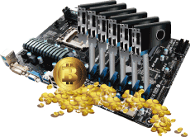
BIO-Flasher

BIO-Flasher is a convenient BIOS update tool. Just launch this tool and put the BIOS on USB pen driver before entering the OS. You can update your BIOS with only a few clicks without preparing an additional floppy disk or other complicated flash utility.
eHot-Line Utiltiy

Integrated e-service automatically sends your technical support request to Biostar Globe tech support without any delay.
A.I FAN

With A.I FAN users can ensure that their gaming PC can maintain its performance while staying cool. According to different cooling needs and usage scenarios, users can control speed modes. Allows users to have more customizability of fan modes and automatically detects different temperatures to make fan operate at defined speed for optimal cooling performance. Furthermore, A.I FAN support both PWM and DC voltage fans for more cooling options.
CPU OPT

BIOSTAR offers one more fan header which is called CPU OPT. Users can use it to connect any kind of water coolers for a liquid cooling system. Keep your computer stable and enjoy your machine at the utmost potential.
Debug LED

Debug LED helps you identify any issues going with your board or hardware. When error occurs, the corresponding LED lights will inform you on the status of your board or hardware to shorten the test time effectively.
A.I TP Control  A.I TP Control is designed for overclockers. It provides a user-friendly BIOS environment that overclockers can adjust the temperature setting to keep your PC safe and enjoy extreme overclocking performance. | 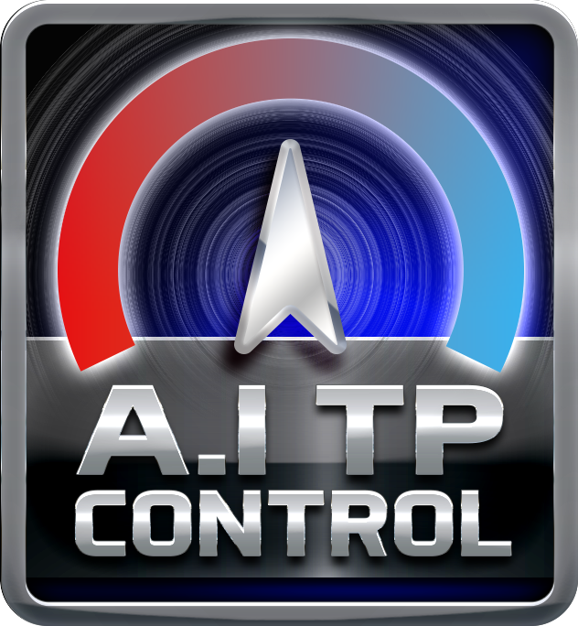
HDMI

The terms HDMI and HDMI High-Definition Multimedia Interface, and the HDMI Logo are trademarks or registered trademarks of HDMI Licensing Administrator, Inc. in the United States and other countries.

