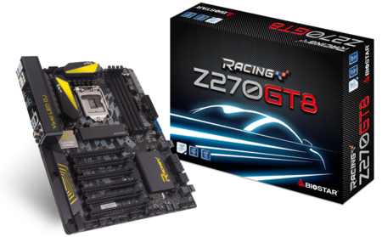 | Z270GT8 5.x  - Supports 7th Generation Intel® Core™ Processor, enables overclocking on Unlocked Intel Core Processors  - Intel Z270 single chip architecture  - Support 4-DIMM DDR4-3600(OC)/ 2400/ 2133/ 1866 up to 64G maximum capacity  - BIOSTAR Double Hi-Fi Technology inside  - Lightning Charger Technology  - Digital Power+ Technology  - Support USB 3.1 Type-C  - Support M.2(32Gb/s)(Intel® Optane™ Technology Ready)  - Support U.2(32Gb/s)(Intel® Optane™ Technology Ready)  - Support HDMI 4K resolution

Chipset | - Intel Z270
CPU SUPPORT | - 7th & 6th Gen Intel® Core™ i7 LGA 1151 Processor  - 7th & 6th Gen Intel® Core™ i5 LGA 1151 Processor  - 7th & 6th Gen Intel® Core™ i3 LGA 1151 Processor  - 7th & 6th Gen Intel® Pentium® LGA 1151 Processor  - 7th & 6th Gen Intel® Celeron® LGA 1151 Processor  - Maximum CPU TDP (Thermal Design Power) : 95Watt
MEMORY | - Support Dual Channel DDR4 3600(OC)/ 2400/ 2133/ 1866 MHz  - 4 x DDR4 DIMM Memory Slot  - Max. Supports up to 64GB Memory
INTEGRATED VIDEO | - By CPU model  - Supports DX12  - Supports HDCP
STORAGE | - 6 x SATA III Connector  - Support SATA RAID: 0,1,5,10  - 2 x U.2 32Gb/s Connector, support PCI-E Storage(share w/ PCI-Ex16_SB_1/PCI-Ex16_SB_3)(Intel® Optane Technology ready)  - 1 x M.2 (M Key) 32Gb/s Connector, support M.2 type 2242/ 2260/ 2280 SATA 6Gb/s(share w/ SATA3_2L) & PCI-E Storage(Intel® Optane Technology ready)  - Support PCI-E Storage RAID: 0,1,5
LAN | - Intel i219V - Gigabit Ethernet PHY
AUDIO CODEC | - Realtek ALC1220 8-Channel Blu-ray Audio  - Support Blu-ray Audio  - Support HD Audio  - Support Biostar Hi-Fi
USB | - 1 x USB 3.1 Type-C Port  - 1 x USB 3.1 Port  - 4 x USB 3.0 Port  - 1 x USB 3.0 Header  - 2 x USB 2.0 Header
EXPANSION SLOT | - 4 x PCI-E 3.0 x16 Slot(x16, x8, x4, x4)  - 2 x PCI-E 3.0 x16 Slot(x4)(Intel® Optane Technology ready)
REAR I/O | - 1 x PS/2  - 1 x USB 3.1 Type-C Port  - 1 x USB 3.1 Port  - 4 x USB 3.0 Port  - 1 x DisplayPort Connector, resolution up to 4096 x 2304 @60Hz(Optional)  - 1 x HDMI Connector, resolution up to 4096 x 2160 @60Hz, compliant with HDMI 2.0  - 1 x HDMI , resolution up to 4096 x 2160 @30Hz, compliant with HDMI 1.4b  - 1 x LAN Port  - 5 x Audio Jacks  - 1 x S/PDIF Out Port
INTERNAL I/O | - 1 x USB 3.0 Header  - 2 x USB 2.0 Header  - 6 x SATA III Connector (6Gb/s)  - 2 x U.2 32Gb/s Connector, support PCI-E Storage(share w/ PCI-Ex16_SB_1/PCI-Ex16_SB_3)(Intel® Optane Technology ready)  - 1 x M.2 Key M 32Gb/s Connector, support M.2 type 2242/ 2260/ 2280 SATA 6Gb/s(share w/ SATA3_2L) & PCI-E Storage(Intel® Optane Technology ready)  - 1 x Front Audio Header  - 1 x Front Panel Header  - 2 x CPU Fan Connector  - 3 x System Fan Connector  - 1 x LN2 Switch  - 2 x 5050 LED Header  - 1 x Thunderbolt 3 Header
H/W MONITORING | - CPU / System Temperature Monitoring  - CPU / System Fan Monitoring  - Smart / Manual CPU / System Fan Control  - System Voltage Monitoring
DIMENSION | - ATX Form Factor Dimension: 30.5cm x 24.4cm ( W x L )
OS SUPPORT | - Supports Windows 10(x64) /11(x64) for Intel 7th Generation Processor  - ※Support Windows 7 / 8.1(x64) / 10(x64) /11(x64) for Intel 6th Generation Processor
BUNDLE SOFTWARE | - Racing GT Utility  - BullGuard  - Intel Rapid Storage Technology
ACCESSORIES | - 4 x SATA Cable  - 1 x I/O Shield  - 1 x DVD Driver  - 1 x User Manual
FEATURES | - VIVID LED DJ  - VIVID LED ARMOR  - 5050 LED FUN ZONE  - Digital Power+  - Lightning Charger  - M.2 Cooling Protection  - Supports Double Hi-Fi  - GT TOUCH  - Supports 100% Solid capacitor  - Rapid Debug3  - Supports Charger Booster  - Supports BIOS Online Update

CPU-Chipset

Intel Z270 chipset  With the Intel® Z270 chipset and the 7th generation Intel® Core™ processors, you will immediately be at the forefront of the battlefield, fueled by mindblowing power and performance. From content creation to gaming, the Intel Z270 chipset provides you with the power and performance you need. | 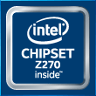
Intel® Optane™ Technology Ready  With Intel® Optane™ technology you can unleash the power of your processor instead of it working at a fraction of its power. Eliminating that bottleneck requires better storage memory that is fast, inexpensive, and non-volatile. Intel® Optane technology has the potential to revolutionize big data, high-performance computing, virtualization, storage, cloud, gaming, and many other applications. | 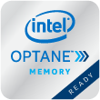

Audio+

Double Hi-Fi

Unlike the previous design thinking, once again BIOSTAR first to embed "Double Hi-Fi" AMP IC, in addition to retaining the exclusive Hi-Fi high-quality without change. "Double Hi-Fi" has brand new features with plug-and-play headphone to enjoy the same quality of sound; whether the sound source output set in the front or rear can have both high-quality Hi-Fi sound.
Blu-ray Audio

Upgrading your Audio performance in the easiest way is choosing BIOSTAR ultimate Motherboard. It does support Blu-ray audio DRM (compatible driver/software) and provide the higher audio output of 24 bit/ 192KHz than the 16 bit/ 48KHz from the normal MB. You will experience the high quality sound effect with pure Blu-Ray Audio.
Hi-Fi Power

Audio power is an important factor in audio quality. Most AV equipment isolates the power supply for each analog and digital signal to gather high-quality sound reproduction. Equipped with BIOSTAR Hi-Fi Power technology, it will utilize audio components with independent power design for a significant reduction in electronic noise and superb sound quality.
Hi-Fi Ground  BIOSTAR Hi-Fi Ground ( Golden Line ) is noise-blocking multi-layer PCB design to isolates analog audio signals from digital sources. Unique PCB layout is ideal for exceptional clarity and high fidelity sound. | 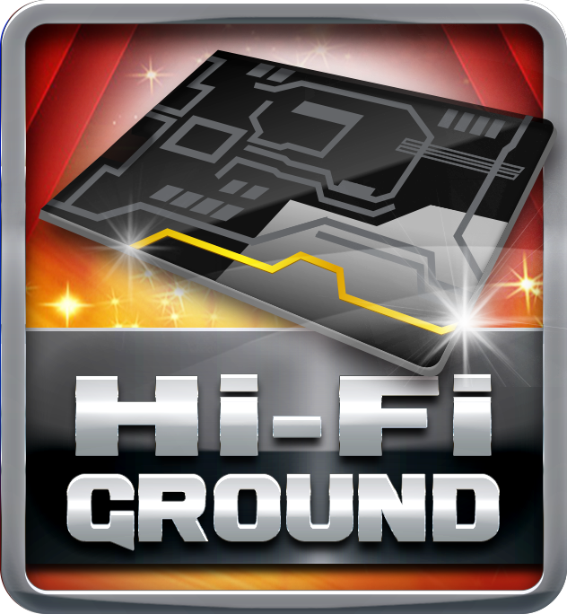
Hi-Fi Sound

BIOSTAR Hi-Fi series motherboards have a sampling rate of 192kHz/24-bit which delivers a high quality audio through an analog connection to your home theater system, multi-channel speakers and high-end headphone. You can enjoy real Blu-ray grade high-definition sound that you’ve never experienced before.
Hi-Fi AMP

The built-in amplifier can drive major high-end headphones with over 100dB loads and offer wide band-width, low noise, high slew rate and low distortion audio source from front panel I/O. Gaming enthusiasts can enjoy a fuller range of dynamic sound with crisper details and less distortion.
Smart Ear

Smart EAR is a windows-based audio utility which allows you to easily adjust system volume. With its user-friendly GUI, you can also increase or decrease impedance setting (Low/High Gain) to optimize your headphone performance. You can easily enjoy high-quality and awesome sound.
Hi-Fi Resistor

Metal-oxide film resistors are made of metal oxides such as tin oxide. The electric characteristics are greater stability and reliability than regular metal film resistors when operating in an extremely broad working temperature range. This special component is used in applications with high endurance audio demands.
Hi-Fi Cap

BIOSTAR Hi-Fi series motherboards come with high quality ‘Non-Polarized Electrolysis Electric audio capacitors’ for each audio channel circuit. The customized audio capacitors deliver low noise, low distortion, and wide bandwidth to achieve the highest sound resolution and sound expansion. The critical component will ensure the most realistic sound effects to gaming enthusiasts.
Hi Fi 120dB

Embrace exceptional sound quality for the win with 120dB SNR and stylish and efficient EMI shield blocks electromagnetic interference to help provide cleaner audio. It has achieved a signal-to-noise ratio (SNR) of 120dB, yielding almost loss-less audio form rear audio connectors.

Video+

HDMI 2.0  HDMI 2.0 supports true 4K resolution- 4096*2160@60hz. A significant increase in bandwidth is up to 18mbps, and significant enhancements are added to support the continued increase consumer demands on video and audio experience. | 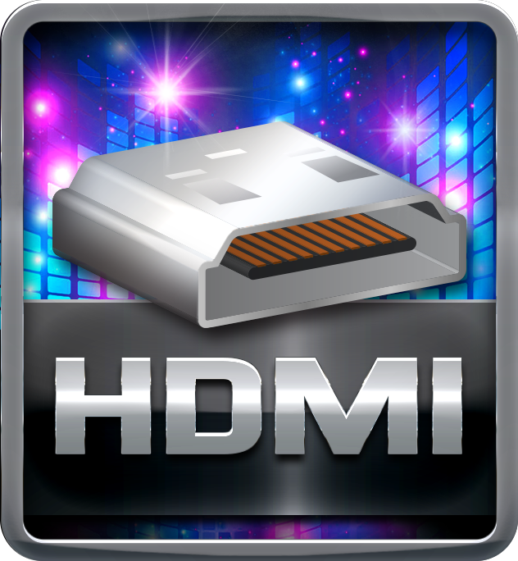
HDMI 4K2K

The new 4K2K resolution enables high-definition image display with four times the resolution of full HD, 4K2K display is faithfully express bright, highly detailed content that fills the entire screen with lifelike images. Connectivity with PCs via a single HDMI cable for displaying 4K2K data.
DisplayPort  DisplayPort is a digital display interface developed by the Video Electronics Standards Association (VESA). The interface is primarily used to connect a video source to a display device such as a computer monitor, though it can also be used to carry audio. | 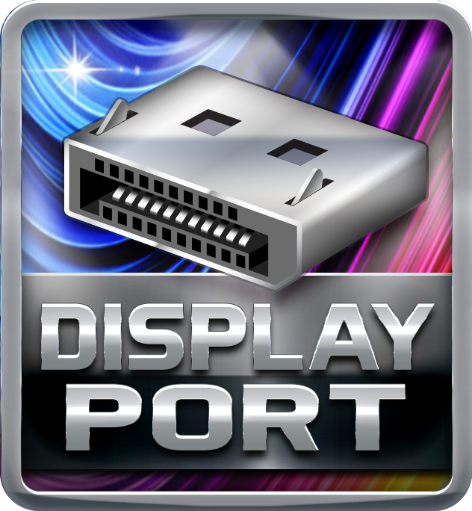
DX12  DirectX 12 introduces the next version of Direct3D, the graphics API at the heart of DirectX. Direct3D is one of the most critical pieces of a game or game engine, and we've redesigned it to be faster and more efficient than ever before. Direct3D 12 enables richer scenes, more objects, and full utilization of modern GPU hardware. | 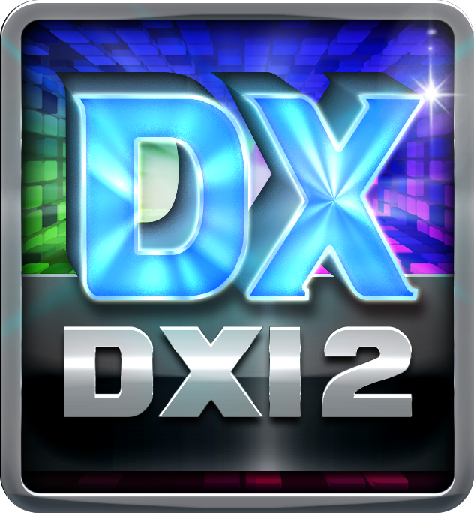

Speed+

Lightning Charger

BIOSTAR new H/W design Lightning Charger supports the functions of USB port and quick charge with the amazingly fast charging time to help your mobile devices achieve up to a 75% charge in just 30 minutes; meanwhile, it supports QC2.0 (up to 12V/1.5A output), APPLE mode (5V/2.4A), and BC1.2.
Intel GbE LAN  Unlike ordinary LAN solution, Intel® GbE LAN offers fewer CPU resource consumption and more bandwidth stability. Thus, Intel® LAN is the best choice for performance seekers. | 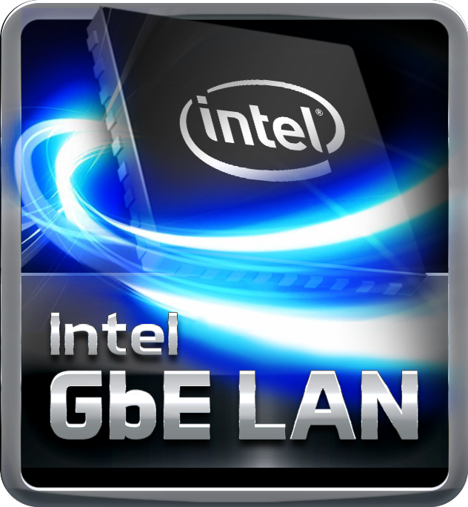
USB 3.1 Type-C

USB 3.1 doubles the data transfer rate from 5Gbps to 10Gbps compared with USB3.0, and also is backward compatible with all existing USB3.0 & USB2.0 devices. The Type-C connector is fully reversible which makes it convenient, and it also can save your charging time on portable devices up to 50% compared with Type-A connector.
USB 3.0

Experience Fastest data transfers at 5 Gbps with USB 3.0--the new latest connectivity standard. Built to connect easily with next-generation components and peripherals, USB 3.0 transfers data 10X faster and backward compatible with previous USB 2.0 components.
USB 3.1

USB 3.1 is a new standard known as SuperSpeed +, in order to highlight the improvement from USB3.0 (SuperSpeed) transmission speed. The new standard doubles data transfer rate from 5Gbps to 10Gbps. It is also backward compatible with existing USB3.0 connectors and all the USB 2.0 devices.
PCIe M.2 32Gb/s  PCI-e M.2 32Gb/s delivers the highest bandwidth and lower latency. It is 3 times faster compared with PCI-e M.2 10Gb/s. | 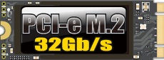
PCIe U.2 Connector

PCIe U.2 connector supports PCIe 3.0 x4 NVMe storage. It delivers the fast bandwidth up to 32Gb/s with stable data transfer and low latency as well. Meanwhile, it is almost 5 times faster than the speed of SATA III interface with 6Gb/s.
PCIe 3.0  PCIe 3.0 is the ubiquitous and general-purpose PCI Express I/O standard. At 8GT/s bit rate, the interconnect performance bandwidth is doubled over PCIe 2.0, while preserving compatibility with software and mechanical interfaces. | 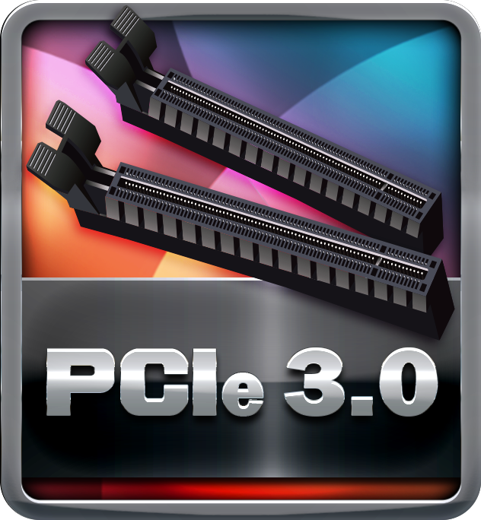
Digital PWM  Digital PWM controller is with dual-output multiphase that faster transient performance and accurately regulated frequency control. It can be enabled to greatly increase system efficiency. | 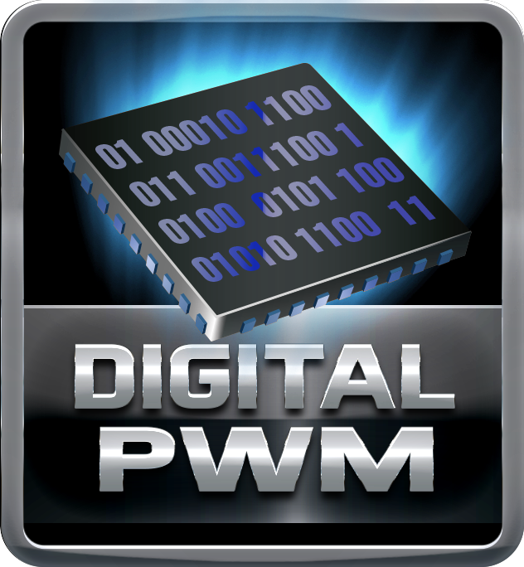

Durable+

Super Durable Ferrite Choke

Super Durable Ferrite Choke brings the benefits of higher current capacity, lower energy loss and better power stability.
Super Durable Solid Caps

The best quality solid state capacitors with ultra low ESR design, the Super Durable Solid Caps doubles the lifespan.
Moistureproof of PCB

The popularity of PC usage and working environment is getting deteriorating and moist (rural, coastal, etc.). The PCB will be oxidizing easily by damp or absorbed moisture, and ionic migration or CAF (Conductive Anodic Filament) will be generated. Moisture-proof PCB meets high density and high reliability requirements for moisture proof.
Low RdsOn P-Pak MOS

Low resistance design can significantly reduce the current out of energy loss.
Low temperature, small size, excellent thermal conductivity.
100% Solid Caps

With armor-plated Biostar Technology, all capacitors are placed with 100% solid capacitors that have a lasting life cycle, durability and stability for crucial components.

Protection+

VIVID LED ARMOR  The new VIVID LED Armor comes with I/O Armor and Audio Armor to protect the I/O interfaces and audio electronic components from static electricity. What’s better, it exclusively features the onboard RGB full-color LED lightings with BIOSTAR VIVID LED DJ application for DIY lovers to create their unique personal styles by changing PC color schemes. | 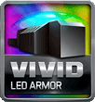
M.2 Cooling Protection  M.2 heatsink features ultra-high cooling efficiency for protecting the M.2 SSD from thermal problems, extending the M.2 SSD lifespan for long-term usage and stable operation. To top it off, this cooling design makes the performance of certain M.2 (PCI-e 3.0x4) products most efficient even under high-temperature operating. | 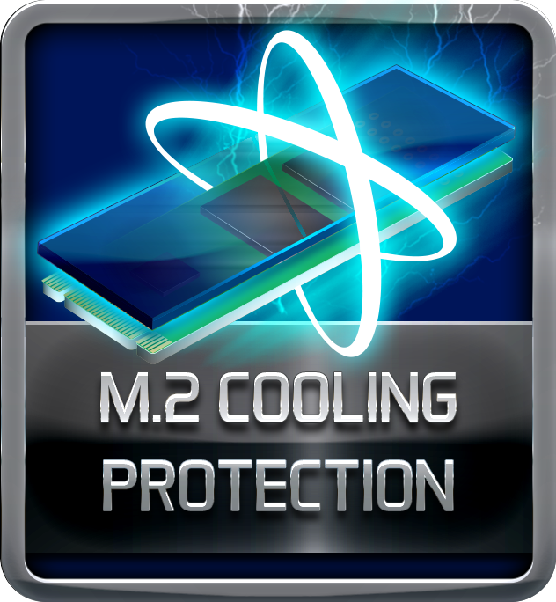
Dual BIOS

Dual BIOS technology offers a backup BIOS chip to take over the failed main BIOS and recover the system automatically without factory repair.
I/O Armor  The Racing I/O Armor protects the I/O panel and electronic components from static electricity, and the streamlined shape serves as a dust guardian, like the F1 racing car. | 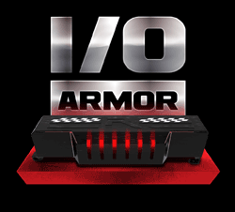
Super Anti-Surge Protection

BIOSTAR exclusive Anti-Surge design provides the best protection of board and extends the product life. Having the latest model of "Transient Voltage Suppressor" on- board can effectively protect the board circuit, reducing the shocks caused by ESD as well as other damages arising from overvoltage transients to enhance system durability.
Super LAN Surge Protection  Super LAN Surge Protection, providing LAN port with more advanced antistatic protection capabilities by adding an integrated chip to strengthen electrical stability and prevent damage from lightning strikes and electrical surges. SLSP (Super LAN Surge Protection) series motherboard upgrades the existing system protection standards with maximum 4X protection comparing to other board makers. | 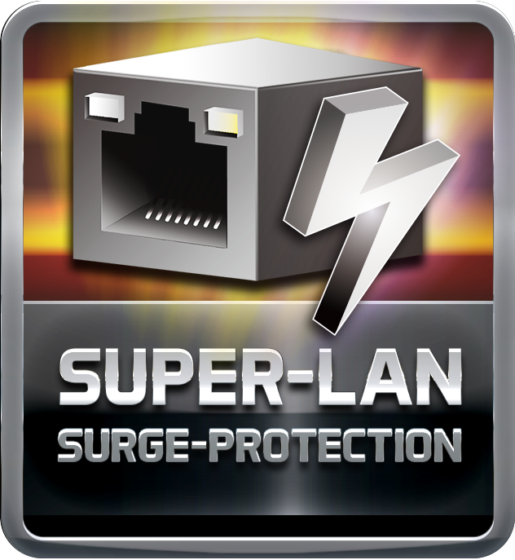
ESD Protection  ESD (Electrostatic Discharge) is the major factor to destroy the PC by electrical overstress (EOS) condition. ESD occurred by PC users when touch any devices connect to a PC, which may result in damage to the motherboard or parts. ESD protection is designed to protect the motherboard and equipment from damage by EOS. | 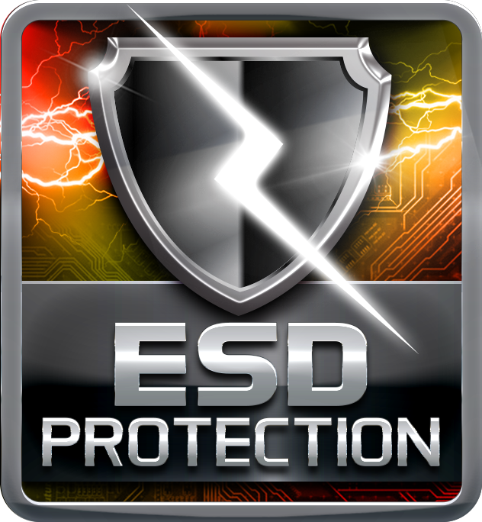
USB Polyswitch

On board dedicated power fuse to help prevent USB port failure. It prevents USB Port overcurrent and safe guard your system and device lifespan.
OC / OV / OH Protection

OC / OV / OH Protection design detects overvoltage conditions and prevents voltage surges from spreading in real time. It also actively cuts off the overvoltage supply to protect your system.

DIY+

VIVID LED DJ  Racing Series exclusively features on-board LED design. Via the creative Vivid LED DJ application, you can control and modify the colours of LED on MOS heatsink and on the edge of board. When you play music, it can perform LED light show, following melody. Moreover, Vivid LED DJ features options for designing LED visual effect, including Normal, Eco, and Sports mode on your own. Racing Series with Vivid LED DJ make your PC a coolest gaming base ever. | 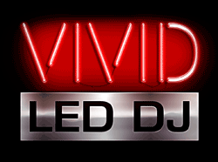
5050 LED FUN

BIOSTAR Racing motherboard comes with the exclusive 5050 LED FUN feature for DIY lovers. You can connect LED strip with on-board 5050 header directly and control it via Vivid LED DJ.
GT TOUCH

GT Touch features exclusive Sport and ECO Mode. Under Sport mode, the system boosts the performance automatically. Under ECO mode, the system optimizes energy consumption. Besides, users could define onboard LED configuration for ECO and Sport Mode respectively via Vivid LED DJ.
UEFI BIOS

Unified Extensible Firmware Interface (UEFI) is a brand new framework that provides a revolutionary interface. It is a modern clear and easy-to-use graphical user interface. The UEFI comes with a colorful easy-understand icons leads users into the setup layer directly.
Header Zone

Users can easily assemble their own computer, a simple-swap data discs and other accessories.
Super Rapid Debug 3

Super Rapid Debug 3 posts critical POST code information on a vivid digital LED display.
Super Durable Box Header

Super Durable Box Header provides solid, secure and durable connections between motherboard and peripheral cables.
LN2 Switch  With LN2 mode activated the BIOSTAR motherboard is optimization to remedy the cold boot bug during POST at an extremely low temperature and help the system boot successfully. | 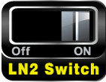
HDMI

The terms HDMI and HDMI High-Definition Multimedia Interface, and the HDMI Logo are trademarks or registered trademarks of HDMI Licensing Administrator, Inc. in the United States and other countries.

