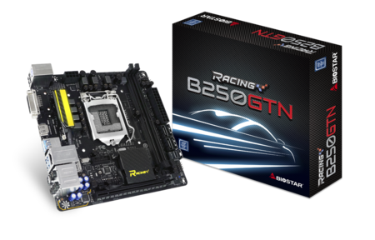 | B250GTN 5.x  - Supports 7th Generation Intel® Core™ Processor  - Intel B250 single chip architecture  - Support 2-DIMM DDR4-2400/ 2133/ 1866 up to 32G maximum capacity  - BIOSTAR Hi-Fi Technology inside  - Support HDMI  - Support U.2 32Gb/s  - Support M.2 32Gb/s

Chipset | - Intel B250
CPU SUPPORT | - 7th & 6th Gen Intel® Core™ i7 LGA 1151 Processor  - 7th & 6th Gen Intel® Core™ i5 LGA 1151 Processor  - 7th & 6th Gen Intel® Core™ i3 LGA 1151 Processor  - 7th & 6th Gen Intel® Pentium® LGA 1151 Processor  - 7th & 6th Gen Intel® Celeron® LGA 1151 Processor  - Maximum CPU TDP (Thermal Design Power) : 95Watt
MEMORY | - Support Dual Channel DDR4 2400/ 2133/ 1866 MHz  - 2 x DDR4 DIMM Memory Slot  - Max. Supports up to 32GB Memory  - * DDR4 2400 for 7th Generation Intel® Core™ Processor Family
INTEGRATED VIDEO | - By CPU model  - Supports DX12  - Supports HDCP
STORAGE | - 4 x SATA III Connector  - 1 x U.2 32Gb/s Connector, support PCI-E Storage(Intel® Optane Technology ready)  - 1 x M.2 (M Key) 32Gb/s Connector, support M.2 type 2260/ 2280 SATA 6Gb/s & PCI-E Storage(on the back of the motherboard)
LAN | - Intel i219V - Gigabit Ethernet PHY  - Support Super LAN Surge Protection
AUDIO CODEC | - Realtek ALC892 8-Channel Blu-ray Audio  - Support HD Audio  - Support Biostar Hi-Fi
USB | - 4 x USB 3.0 Port  - 1 x USB 3.0 Header  - 2 x USB 2.0 Port  - 1 x USB 2.0 Header
EXPANSION SLOT | - 1 x PCI-E 3.0 x16 Slot
REAR I/O | - 1 x PS/2 Keyboard/Mouse  - 4 x USB 3.0 Port  - 2 x USB 2.0 Port  - 1 x HDMI Connector, resolution up to 4096 x 2160 @30Hz, compliant with HDMI 1.4b  - 1 x DVI-D Connector, resolution up to 1920 x 1200 @60Hz  - 1 x LAN Port  - 5 x Audio Jacks  - 1 x S/PDIF Out Port
INTERNAL I/O | - 1 x USB 3.0 Header  - 1 x USB 2.0 Header  - 4 x SATA III Connector (6Gb/s)  - 1 x U.2 32Gb/s Connector, support PCI-E Storage(Intel® Optane Technology ready)  - 1 x M.2 Key M 32Gb/s Connector, support M.2 type 2260/ 2280 SATA 6Gb/s & PCI-E Storage(Intel® Optane Technology ready)(on the back of the motherboard)  - 1 x Front Audio Header  - 1 x Front Panel Header  - 1 x CPU Fan Connector  - 1 x System Fan Connector  - 2 x 5050 LED Header
H/W MONITORING | - CPU / System Temperature Monitoring  - CPU / System Fan Monitoring  - Smart / Manual CPU / System Fan Control  - System Voltage Monitoring
DIMENSION | - Mini ITX Form Factor Dimension: 17cm x 17cm ( W x L )
OS SUPPORT | - Supports Windows 10(x64) / 11(x64) for Intel 7th Generation Processor  - ※Support Windows 7 / 8.1(x64) / 10(x64) / 11(x64) for Intel 6th Generation Processor
BUNDLE SOFTWARE | - Racing GT Utility  - BullGuard  - Intel Rapid Storage Technology
ACCESSORIES | - 4 x SATA Cable  - 1 x I/O Shield  - 1 x DVD Driver  - 1 x Quick Guide
FEATURES | - VIVID LED DJ  - 5050 LED FUN ZONE  - Supports PURO Hi-Fi  - Supports 100% Solid capacitor  - Supports Charger Booster  - Supports BIOS Online Update

CPU-Chipset

Intel B250 chipset  Give your small business a boost with the Intel® B250 Chipset and the 7th Generation Intel® Core™ processor. The Intel B250 chipset provides you with the power and performance you need for your small business. | 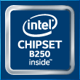

Audio+

Hi-Fi

A combination of exclusive hardware &amp; software design including &quot;ground-isolation circuit design&quot;,&quot;an independent audio power&quot;, and &quot;a built=on-board amplifier&quot;, with all these hardware features gives you the best audio quality and performance. As for software, we offer you a free bundle utility &quot;Multi-Channel Calibration&quot; which normally you'll find in high level sound systems; this feature allows you to auto detect your location; with a user friendly interface, you can easily adjust the volume of every speakers to make a well balanced surround sound. And of course, the built-on-board amplifier always gives you a super powerful sound comparing to other motherboards.
Blu-ray Audio

Upgrading your Audio performance in the easiest way is choosing BIOSTAR ultimate Motherboard. It does support Blu-ray audio DRM (compatible driver/software) and provide the higher audio output of 24 bit/ 192KHz than the 16 bit/ 48KHz from the normal MB. You will experience the high quality sound effect with pure Blu-Ray Audio.
MCC  Multi Channels Calibration (MCC) can transform any room into the ideal listening environment. With Multi Channels Calibration (MCC), audio performance is automatically calibrated according to the dimensions of your room. Simply place the speaker and setup the microphone at your usual listening spot, position the speakers and connect them. The users can set up the speaker settings easily by using a free bundle MCC software. | 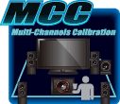
Hi-Fi Power

Audio power is an important factor in audio quality. Most AV equipment isolates the power supply for each analog and digital signal to gather high-quality sound reproduction. Equipped with BIOSTAR Hi-Fi Power technology, it will utilize audio components with independent power design for a significant reduction in electronic noise and superb sound quality.
Hi-Fi Ground  BIOSTAR Hi-Fi Ground ( Golden Line ) is noise-blocking multi-layer PCB design to isolates analog audio signals from digital sources. Unique PCB layout is ideal for exceptional clarity and high fidelity sound. | 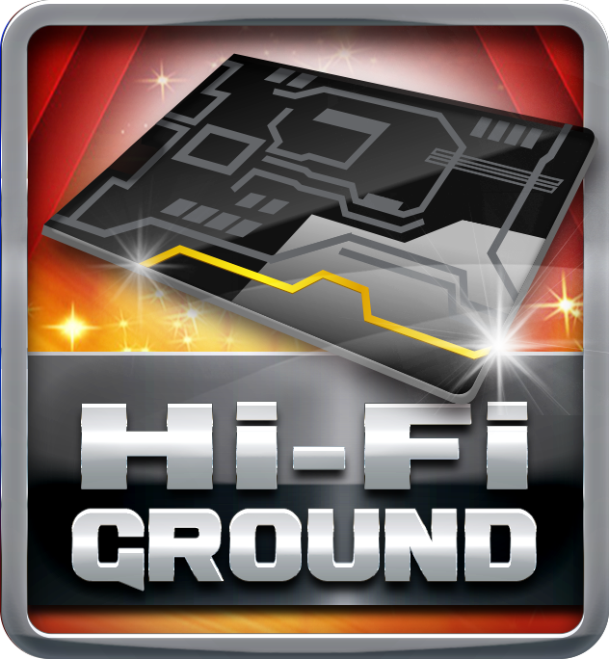
Hi-Fi Sound

BIOSTAR Hi-Fi series motherboards have a sampling rate of 192kHz/24-bit which delivers a high quality audio through an analog connection to your home theater system, multi-channel speakers and high-end headphone. You can enjoy real Blu-ray grade high-definition sound that you’ve never experienced before.
Hi-Fi AMP

The built-in amplifier can drive major high-end headphones with over 100dB loads and offer wide band-width, low noise, high slew rate and low distortion audio source from front panel I/O. Gaming enthusiasts can enjoy a fuller range of dynamic sound with crisper details and less distortion.
Smart Ear

Smart EAR is a windows-based audio utility which allows you to easily adjust system volume. With its user-friendly GUI, you can also increase or decrease impedance setting (Low/High Gain) to optimize your headphone performance. You can easily enjoy high-quality and awesome sound.
Hi-Fi Resistor

Metal-oxide film resistors are made of metal oxides such as tin oxide. The electric characteristics are greater stability and reliability than regular metal film resistors when operating in an extremely broad working temperature range. This special component is used in applications with high endurance audio demands.
Hi-Fi Cap

BIOSTAR Hi-Fi series motherboards come with high quality ‘Non-Polarized Electrolysis Electric audio capacitors’ for each audio channel circuit. The customized audio capacitors deliver low noise, low distortion, and wide bandwidth to achieve the highest sound resolution and sound expansion. The critical component will ensure the most realistic sound effects to gaming enthusiasts.
Hi-Fi 110dB+

Embrace exceptional sound quality for the win with 110dB SNR and stylish and efficient EMI shield blocks electromagnetic interference to help provide cleaner audio. It has achieved a signal-to-noise ratio (SNR) of 110dB, yielding almost loss-less audio form rear audio connectors.

Video+

HDMI 2.0  HDMI 2.0 supports true 4K resolution- 4096*2160@60hz. A significant increase in bandwidth is up to 18mbps, and significant enhancements are added to support the continued increase consumer demands on video and audio experience. | 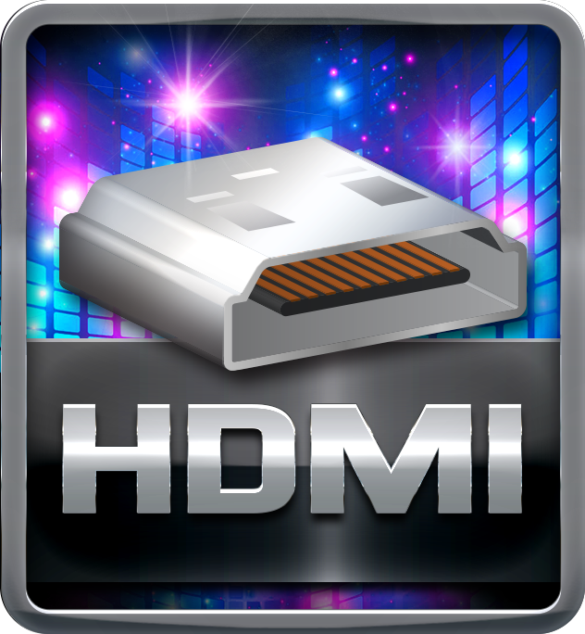
HDMI 4K2K

The new 4K2K resolution enables high-definition image display with four times the resolution of full HD, 4K2K display is faithfully express bright, highly detailed content that fills the entire screen with lifelike images. Connectivity with PCs via a single HDMI cable for displaying 4K2K data.
DVI  DVI is better than VGA for LCD displays since it is digital while VGA is analog. For LCD displays, the picture is digitized pixel per pixel. Through DVI, the panel gets data for each pixel, so the picture generated in the Graphics device matches the pixels on the panel itself. | 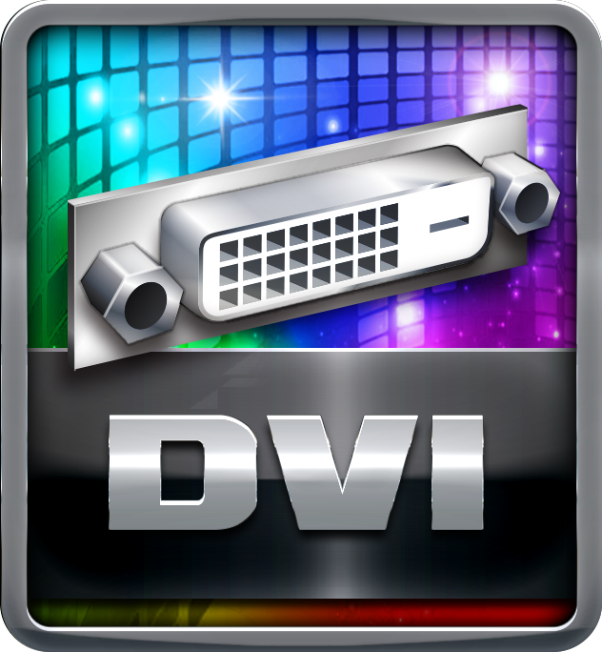
DX12  DirectX 12 introduces the next version of Direct3D, the graphics API at the heart of DirectX. Direct3D is one of the most critical pieces of a game or game engine, and we've redesigned it to be faster and more efficient than ever before. Direct3D 12 enables richer scenes, more objects, and full utilization of modern GPU hardware. | 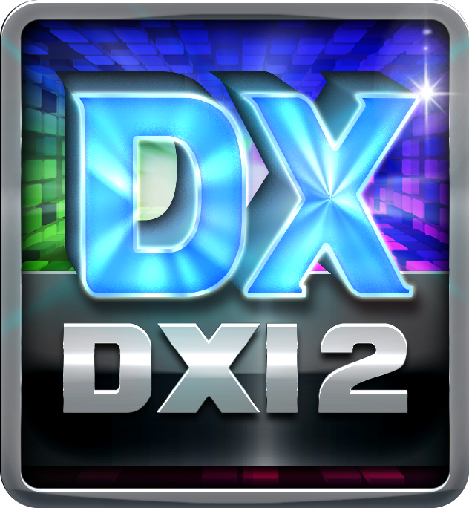

Speed+

Intel GbE LAN  Unlike ordinary LAN solution, Intel® GbE LAN offers fewer CPU resource consumption and more bandwidth stability. Thus, Intel® LAN is the best choice for performance seekers. | 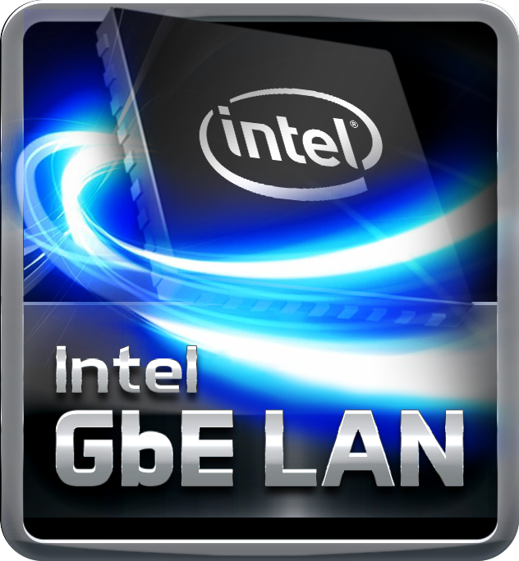
Charger Booster II

Charger booster 2, with maximum voltage up to 2A which provides a quicker charging time on various portable devices.
PCIe 3.0  PCIe 3.0 is the ubiquitous and general-purpose PCI Express I/O standard. At 8GT/s bit rate, the interconnect performance bandwidth is doubled over PCIe 2.0, while preserving compatibility with software and mechanical interfaces. | 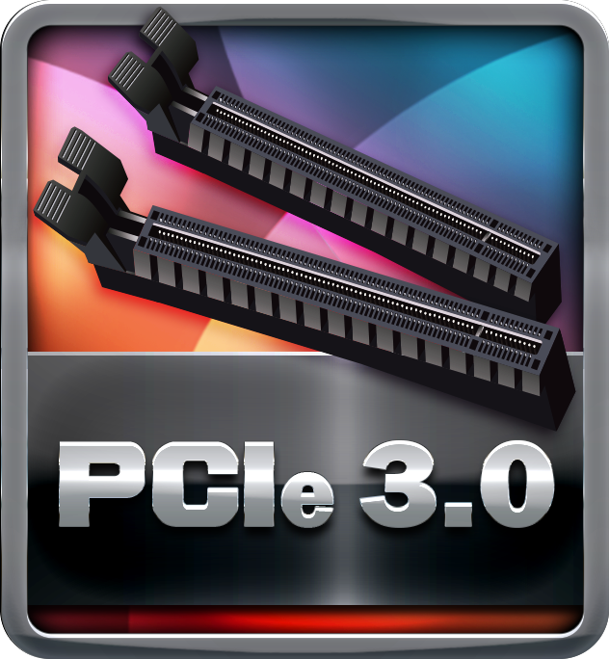

Durable+

Super Durable Ferrite Choke

Super Durable Ferrite Choke brings the benefits of higher current capacity, lower energy loss and better power stability.
Super Durable Solid Caps

The best quality solid state capacitors with ultra low ESR design, the Super Durable Solid Caps doubles the lifespan.
Moistureproof of PCB

The popularity of PC usage and working environment is getting deteriorating and moist (rural, coastal, etc.). The PCB will be oxidizing easily by damp or absorbed moisture, and ionic migration or CAF (Conductive Anodic Filament) will be generated. Moisture-proof PCB meets high density and high reliability requirements for moisture proof.
Low RdsOn P-Pak MOS

Low resistance design can significantly reduce the current out of energy loss.
Low temperature, small size, excellent thermal conductivity.

Protection+

Super Anti-Surge Protection

BIOSTAR exclusive Anti-Surge design provides the best protection of board and extends the product life. Having the latest model of "Transient Voltage Suppressor" on- board can effectively protect the board circuit, reducing the shocks caused by ESD as well as other damages arising from overvoltage transients to enhance system durability.
Super LAN Surge Protection  Super LAN Surge Protection, providing LAN port with more advanced antistatic protection capabilities by adding an integrated chip to strengthen electrical stability and prevent damage from lightning strikes and electrical surges. SLSP (Super LAN Surge Protection) series motherboard upgrades the existing system protection standards with maximum 4X protection comparing to other board makers. | 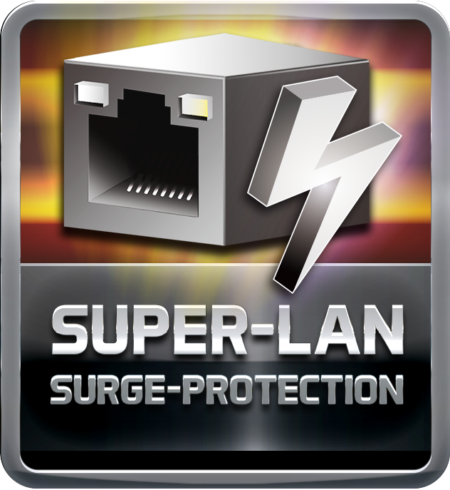
ESD Protection  ESD (Electrostatic Discharge) is the major factor to destroy the PC by electrical overstress (EOS) condition. ESD occurred by PC users when touch any devices connect to a PC, which may result in damage to the motherboard or parts. ESD protection is designed to protect the motherboard and equipment from damage by EOS. | 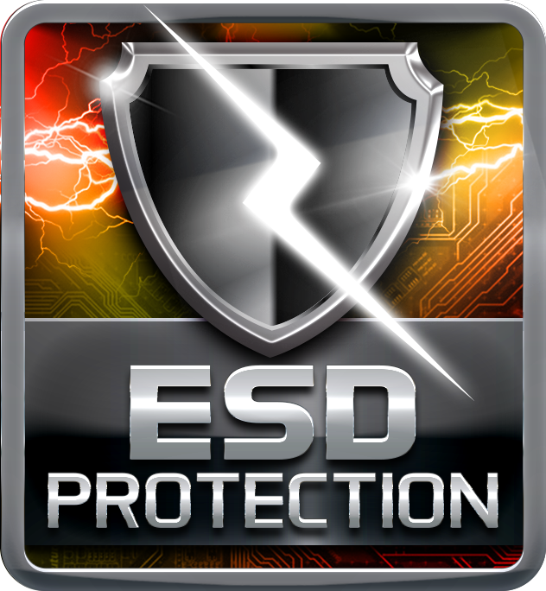
OC / OV / OH Protection

OC / OV / OH Protection design detects overvoltage conditions and prevents voltage surges from spreading in real time. It also actively cuts off the overvoltage supply to protect your system.

DIY+

VIVID LED DJ  Racing Series exclusively features on-board LED design. Via the creative Vivid LED DJ application, you can control and modify the colours of LED on MOS heatsink and on the edge of board. When you play music, it can perform LED light show, following melody. Moreover, Vivid LED DJ features options for designing LED visual effect, including Normal, Eco, and Sports mode on your own. Racing Series with Vivid LED DJ make your PC a coolest gaming base ever. | 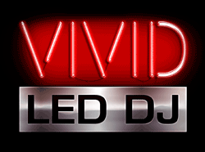
5050 LED Fun ZONE

The brand-new 5050 LED FUN ZONE comes with two 5050 LED headers to bring more colorful lighting options to DIY lovers. They can fully enjoy the DIY fun of modding their PCs with uniquely personal style and LED strip or any kind of LED product to adjust the color of LED and change system color scheme by VIVID LED DJ application. Vivid LED DJ fun, Vivid LED lighting style!
UEFI BIOS

Unified Extensible Firmware Interface (UEFI) is a brand new framework that provides a revolutionary interface. It is a modern clear and easy-to-use graphical user interface. The UEFI comes with a colorful easy-understand icons leads users into the setup layer directly.
Header Zone

Users can easily assemble their own computer, a simple-swap data discs and other accessories.
HDMI

The terms HDMI and HDMI High-Definition Multimedia Interface, and the HDMI Logo are trademarks or registered trademarks of HDMI Licensing Administrator, Inc. in the United States and other countries.

