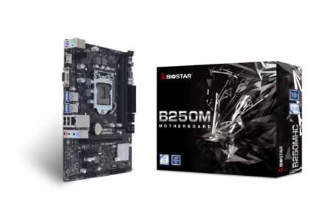 | B250MHC 7.0  - Supports 6th / 7th Generation Intel Core™ Processor  - Intel B250 single chip architecture  - Supports 2-DIMM DDR4-1866/ 2133/ 2400 up to 32G maximum capacity  - Supports HD Audio  - Supports HDMI

Chipset | - Intel B250
CPU SUPPORT | - Support for 6th/ 7th Generation Intel Core i7/ i5/ i3 processors and Intel Pentium processors/ Intel Celeron processors in the LGA1511 package  - * Please refer to www.biostar.com.tw for CPU support list.
MEMORY | - Supports Dual Channel DDR4 1866/2133/2400  - 2 x DDR4 DIMM Memory Slot, Max. Supports up to 32 GB Memory  - Each DIMM supports non-ECC 4/8/16GB DDR4 module  - * DDR4-2400 for 7th Generation Intel Core™ Processor Family.  - * Please refer to www.biostar.com.tw for Memory support list.
INTEGRATED VIDEO | - By CPU model  - Supports DX12  - Supports HDCP
STORAGE | - 4 x SATA III Connectors (6Gb/s) : Supports AHCI
LAN | - RTL8111H  - 10/ 100/ 1000 Mb/s auto negotiation, Half / Full duplex capability  - Supports Super LAN Surge Protection
AUDIO CODEC | - ALC887  - 7.1 Channels, High Definition Audio
USB | - 6 x USB 3.2 (Gen1) ports (4 on rear I/Os and 2 via internal header)  - 6 x USB 2.0 ports (2 on rear I/Os and 4 via internal header)
EXPANSION SLOT | - 2 x PCIe 3.0 x 1 Slot  - 1 x PCIe 3.0 x 16 Slot
REAR I/O | - 1 x PS/2 Mouse Port  - 1 x PS/2 Keyboard Port  - 1 x VGA Port  - 1 x HDMI Port  - 1 x LAN Port  - 2 x USB 2.0 Ports  - 4 x USB 3.2 (Gen1) Ports  - 3 x Audio Jack
INTERNAL I/O | - 4 x SATA III Connectors (6Gb/s)  - 2 x USB 2.0 Headers (each header supports 2 USB 2.0 ports)  - 1 x USB 3.2(Gen1) Header (each header supports 2 USB 3.2(Gen1) ports)  - 1 x 4-Pin Power Connector  - 1 x 24-Pin Power Connector  - 1 x CPU Fan Connector  - 1 x System Fan Connector  - 1 x Front Panel Header  - 1 x Front Audio Header  - 1 x Clear CMOS Header  - 1 x COM Port Header
H/W MONITORING | - CPU / System Temperature Monitoring  - CPU / System Fan Monitoring  - Smart / Manual CPU Fan Control  - CPU/DDR Voltage Monitoring
DIMENSION | - Micro ATX Form Factor Dimension: 22.6cm x 17.1cm ( W x L )
OS SUPPORT | - Supports Windows 7 (32/64bit) / 8.1(64bit) /10(64bit) / 11(64bit)  - ※Windows 7 (32/64bit) / 8.1(64bit) for 6th Generation Intel Core™ Processor Family only.<BR>※Biostar reserves the right to add or remove support for any OS with or without notice.
BUNDLE SOFTWARE | - BullGuard  - Smart Speed LAN
ACCESSORIES | - 2 x SATA Cable  - 1 x I/O Shield  - 1 x DVD Driver  - 1 x Quick Guide
FEATURES | - BIO-FLASHER

CPU-Chipset

Intel B250 chipset  Give your small business a boost with the Intel® B250 Chipset and the 7th Generation Intel® Core™ processor. The Intel B250 chipset provides you with the power and performance you need for your small business. | 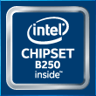

Audio+

HD Audio

Provides high quality sound with minimal loss of audio fidelity.

Video+

HDMI 4K2K  The new 4K2K resolution enables high-definition image display with four times the resolution of full HD, 4K2K display is faithfully express bright, highly detailed content that fills the entire screen with lifelike images. Connectivity with PCs via a single HDMI cable for displaying 4K2K data. | 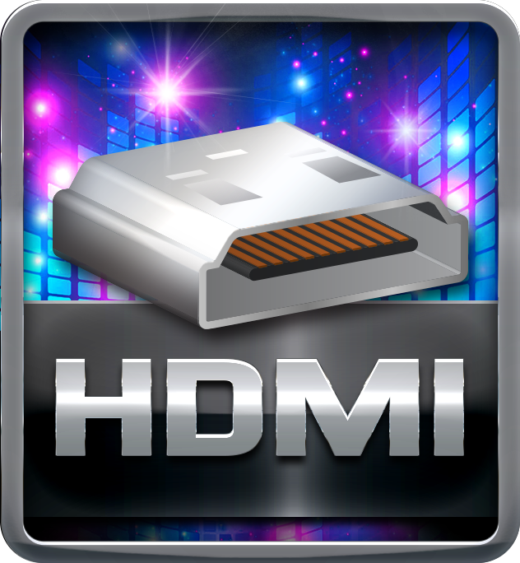
DX12  DirectX 12 introduces the next version of Direct3D, the graphics API at the heart of DirectX. Direct3D is one of the most critical pieces of a game or game engine, and we've redesigned it to be faster and more efficient than ever before. Direct3D 12 enables richer scenes, more objects, and full utilization of modern GPU hardware. | 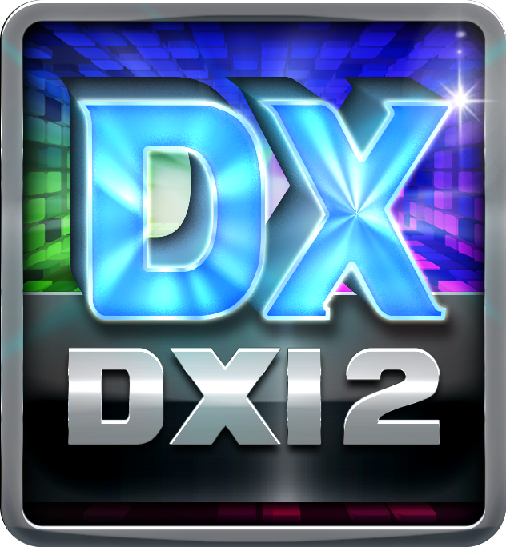

Speed+

SmartSpeedLAN

SmartSpeedLAN is a free software application which monitors and manages your PC's network behavior. With user-friendly GUI, it allows you to select and prioritize different types of network traffic, including gaming, media streaming, communications or web surfing.You can also set any specific applications, choosing to prioritize or block accordingly. SmartSpeedLAN can feature automatic management options that use adaptive networking intelligence to ensure that you are getting the best online experience possible.
PCIe 3.0  PCIe 3.0 is the ubiquitous and general-purpose PCI Express I/O standard. At 8GT/s bit rate, the interconnect performance bandwidth is doubled over PCIe 2.0, while preserving compatibility with software and mechanical interfaces. | 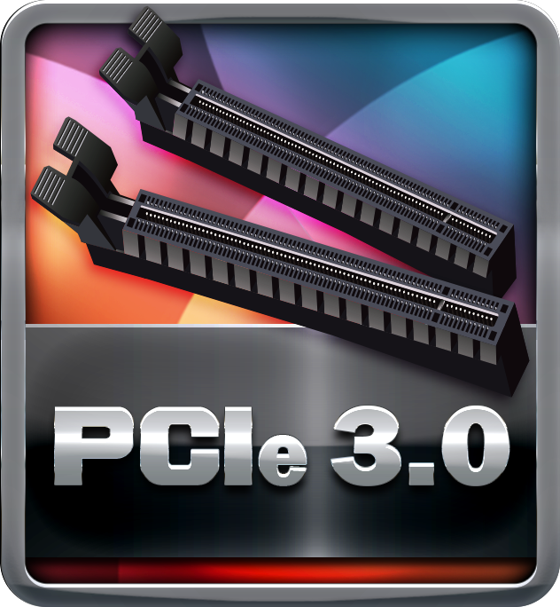
SATAIII 6Gbps  SATAIII 6Gbps provides a higher bandwidth to retrieve and transfer HD media. With this super speed data transfer, SATAIII allows an incredible data boost which is 2x faster than the SATA II. | 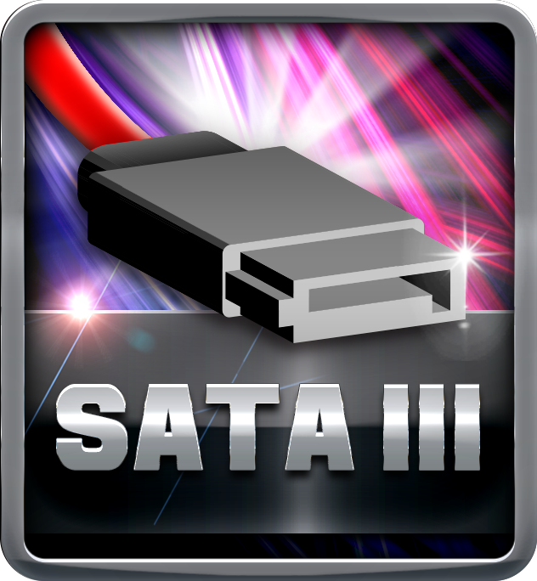
Dual DDR4  The primary advantages of DDR4 over DDR3, include higher module density, lower voltage requirements, coupled with higher data transfer rate. | 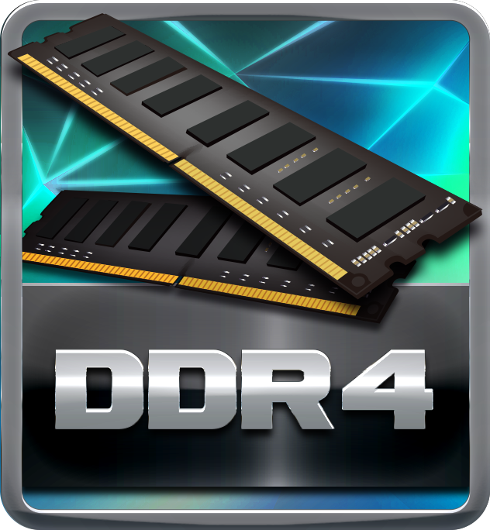
USB 3.2 Gen1 Type-A  USB 3.2 Gen1 delivers a compelling performance boosts and can be used to connect multiple devices without worrying about compatibility. It is capable of data transfer speeds up to 5Gbps and backwards compatible with all existing USB products. | 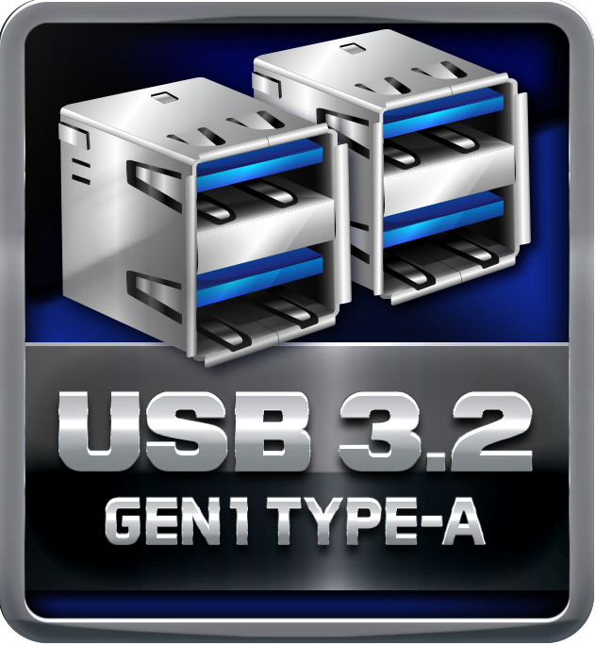

Protection+

Super LAN Surge Protection

Super LAN Surge Protection, providing LAN port with more advanced antistatic protection capabilities by adding an integrated chip to strengthen electrical stability and prevent damage from lightning strikes and electrical surges. SLSP (Super LAN Surge Protection) series motherboard upgrades the existing system protection standards with maximum 4X protection comparing to other board makers.
ESD Protection  ESD (Electrostatic Discharge) is the major factor to destroy the PC by electrical overstress (EOS) condition. ESD occurred by PC users when touch any devices connect to a PC, which may result in damage to the motherboard or parts. ESD protection is designed to protect the motherboard and equipment from damage by EOS. | 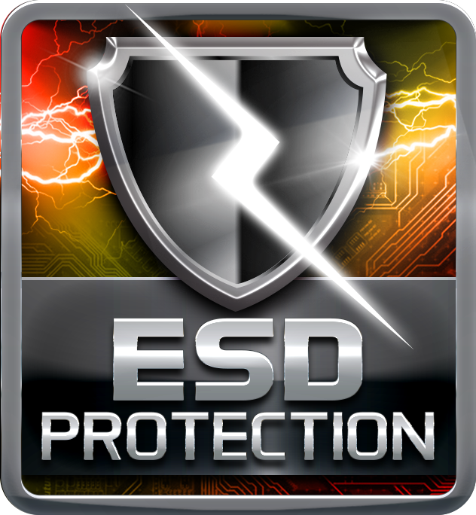
USB Polyswitch

On board dedicated power fuse to help prevent USB port failure. It prevents USB Port overcurrent and safe guard your system and device lifespan.
HDMI

The terms HDMI and HDMI High-Definition Multimedia Interface, and the HDMI Logo are trademarks or registered trademarks of HDMI Licensing Administrator, Inc. in the United States and other countries.

