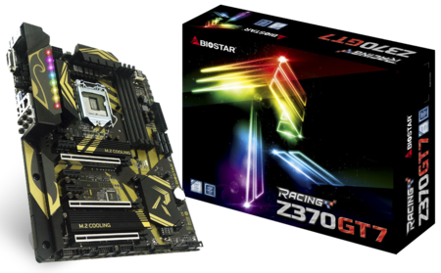 | Z370GT7 5.x  - Supports 9th & 8th Generation Intel® Core™ Processor, enables overclocking on Unlocked Intel Core Processors  - Intel Z370 single chip architecture  - Support 4-DIMM DDR4-3866(OC)/ 3600(OC)/ 3200(OC)/ 2933(OC)/ 2666(OC)/ 2400/ 2133/ 1866 up to 64G maximum capacity  - BIOSTAR Hi-Fi Technology inside  - Support USB 3.1  - Support M.2(32Gb/s)(Intel® Optane™ Technology Ready)  - Support HDMI 4K resolution

Chipset | - Intel Z370
CPU SUPPORT | - 9th Gen Intel® Core™ i9 LGA 1151 Processor  - 9th Gen Intel® Core™ i7 LGA 1151 Processor  - 9th Gen Intel® Core™ i5 LGA 1151 Processor  - 9th Gen Intel® Core™ i3 LGA 1151 Processor  - 8th Gen Intel® Core™ i7 LGA 1151 Processor  - 8th Gen Intel® Core™ i5 LGA 1151 Processor  - 8th Gen Intel® Core™ i3 LGA 1151 Processor  - 8th Gen Intel® Pentium® LGA 1151 Processor  - 8th Gen Intel® Celeron® LGA 1151 Processor  - Maximum CPU TDP (Thermal Design Power) : 95Watt
MEMORY | - Support Dual Channel DDR4 3866(OC)/ 3600(OC)/ 3200(OC)/ 2933(OC)/ 2666(OC)/ 2400/ 2133/ 1866 MHz  - 4 x DDR4 DIMM Memory Slot  - Max. Supports up to 64GB Memory
INTEGRATED VIDEO | - By CPU model  - Supports DX12  - Supports HDCP
STORAGE | - 6 x SATA III Connectors (6Gb/s)  - Support SATA RAID: 0,1,5,10  - 1 x M.2 (M Key) 32Gb/s Connector, support M.2 type 2242/ 2260/ 2280 SATA III (6Gb/s) & PCI-E (32Gb/s) Storage(Intel Optane Technology ready)  - 1 x M.2 (M Key) 32Gb/s Connector, support M.2 type 2242/ 2260/ 2280/ 22110 PCI-E (32Gb/s) Storage(Intel Optane Technology ready)  - Support PCI-E Storage RAID: 0,1
LAN | - Intel i219V - Gigabit Ethernet PHY  - Support Super LAN Surge Protection
AUDIO CODEC | - Realtek ALC1220 8-Channel Blu-ray Audio  - Support Blu-ray Audio  - Support HD Audio  - Support Biostar Hi-Fi
USB | - 2 x USB 3.1 Gen2 Type-A Port  - 1 x USB 3.1 Gen1 Type-C Port  - 2 x USB 3.1 Gen1 Port  - 2 x USB 3.1 Gen1 Header  - 2 x USB 2.0 Port  - 2 x USB 2.0 Header
EXPANSION SLOT | - 3 x PCI-E 3.0 x16 Slot(x8,x8,x4)(x4 shared bandwidth with M.2_2, support Intel Rapid Storage Technology)  - 3 x PCI-E 3.0 x1 Slot
REAR I/O | - 1 x PS/2 Keyboard/Mouse  - 2 x USB 3.1 Gen2 Type-A Port  - 1 x USB 3.1 Gen1 Type-C Port  - 2 x USB 3.1 Gen1 Port  - 2 x USB 2.0 Port  - 1 x HDMI Connector, resolution up to 4096 x 2160 @30Hz, compliant with HDMI 1.4  - 1 x DVI-D Connector, resolution up to 1920 x 1200 @60Hz  - 1 x LAN Port  - 6 x Audio Jacks
INTERNAL I/O | - 2 x USB 3.1 Gen1 Header  - 2 x USB 2.0 Header  - 6 x SATA III Connector(when using SATA SSD on M.2_1, SATA3_1 will be disable) (6Gb/s)  - 1 x M.2 Key M 32Gb/s Connector, support M.2 type 2242/ 2260/ 2280 SATA 6Gb/s & PCI-E Storage(Intel Optane Technology ready)  - 1 x M.2 Key M 32Gb/s Connector, support M.2 type 2242/ 2260/ 2280/ 22110 PCI-E Storage(Intel Optane Technology ready)  - 1 x Front Audio Header  - 1 x Front Panel Header  - 1 x S/PDIF-Out Header  - 2 x CPU Fan Connector  - 3 x System Fan Connector  - 1 x LN2 Switch  - 2 x 5050 LED Header
H/W MONITORING | - CPU / System Temperature Monitoring  - CPU / System Fan Monitoring  - Smart / Manual CPU / System Fan Control  - System Voltage Monitoring
DIMENSION | - ATX Form Factor Dimension: 30.5cm x 24.4cm ( W x L )
OS SUPPORT | - Supports Windows 10(x64)
BUNDLE SOFTWARE | - Racing GT Utility  - BullGuard  - Intel Rapid Storage Technology
ACCESSORIES | - 4 x SATA Cable  - 1 x I/O Shield  - 1 x DVD Driver  - 1 x User Manual
FEATURES | - VIVID LED DJ  - 5050 LED FUN ZONE  - M.2 Cooling Protection  - Supports Double Hi-Fi  - GT TOUCH  - Supports 100% Solid capacitor  - Rapid Debug3  - Supports Charger Booster  - Supports BIOS Online Update  - A.I FAN

CPU-Chipset

Intel Z370 chipset  With the Intel® Z370 chipset and the 8th generation Intel® Core™ processors, you will immediately be at the forefront of the battlefield, fueled by mindblowing power and performance. From content creation to gaming, the Intel Z370 chipset provides you with the power and performance you need. | 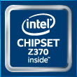

Audio+

Double Hi-Fi

Unlike the previous design thinking, once again BIOSTAR first to embed "Double Hi-Fi" AMP IC, in addition to retaining the exclusive Hi-Fi high-quality without change. "Double Hi-Fi" has brand new features with plug-and-play headphone to enjoy the same quality of sound; whether the sound source output set in the front or rear can have both high-quality Hi-Fi sound.
Blu-ray Audio

Upgrading your Audio performance in the easiest way is choosing BIOSTAR ultimate Motherboard. It does support Blu-ray audio DRM (compatible driver/software) and provide the higher audio output of 24 bit/ 192KHz than the 16 bit/ 48KHz from the normal MB. You will experience the high quality sound effect with pure Blu-Ray Audio.
Hi-Fi Power

Audio power is an important factor in audio quality. Most AV equipment isolates the power supply for each analog and digital signal to gather high-quality sound reproduction. Equipped with BIOSTAR Hi-Fi Power technology, it will utilize audio components with independent power design for a significant reduction in electronic noise and superb sound quality.
Hi-Fi Ground  BIOSTAR Hi-Fi Ground ( Golden Line ) is noise-blocking multi-layer PCB design to isolates analog audio signals from digital sources. Unique PCB layout is ideal for exceptional clarity and high fidelity sound. | 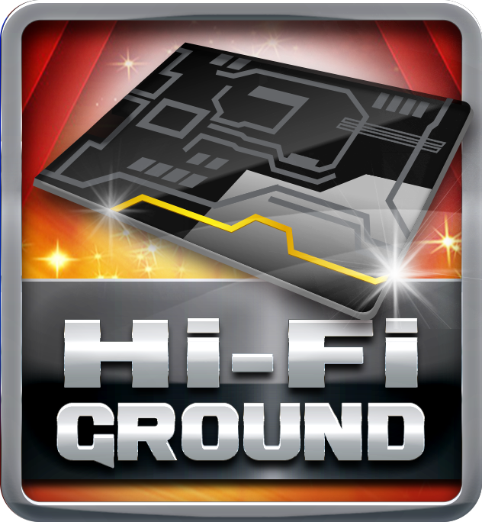
Hi-Fi Sound

BIOSTAR Hi-Fi series motherboards have a sampling rate of 192kHz/24-bit which delivers a high quality audio through an analog connection to your home theater system, multi-channel speakers and high-end headphone. You can enjoy real Blu-ray grade high-definition sound that you’ve never experienced before.
Hi-Fi AMP

The built-in amplifier can drive major high-end headphones with over 100dB loads and offer wide band-width, low noise, high slew rate and low distortion audio source from front panel I/O. Gaming enthusiasts can enjoy a fuller range of dynamic sound with crisper details and less distortion.
Smart Ear

Smart EAR is a windows-based audio utility which allows you to easily adjust system volume. With its user-friendly GUI, you can also increase or decrease impedance setting (Low/High Gain) to optimize your headphone performance. You can easily enjoy high-quality and awesome sound.
Hi-Fi Resistor

Metal-oxide film resistors are made of metal oxides such as tin oxide. The electric characteristics are greater stability and reliability than regular metal film resistors when operating in an extremely broad working temperature range. This special component is used in applications with high endurance audio demands.
Hi-Fi Cap

Hi-Fi Cap delivers low noise, low distortion, and wide bandwidth to achieve the highest sound resolution and sound expansion. It ensures the most realistic sound effects to gaming enthusiasts.
Hi Fi 120dB

Embrace exceptional sound quality for the win with 120dB SNR and stylish and efficient EMI shield blocks electromagnetic interference to help provide cleaner audio. It has achieved a signal-to-noise ratio (SNR) of 120dB, yielding almost loss-less audio form rear audio connectors.

Video+

HDMI 4K2K  The new 4K2K resolution enables high-definition image display with four times the resolution of full HD, 4K2K display is faithfully express bright, highly detailed content that fills the entire screen with lifelike images. Connectivity with PCs via a single HDMI cable for displaying 4K2K data. | 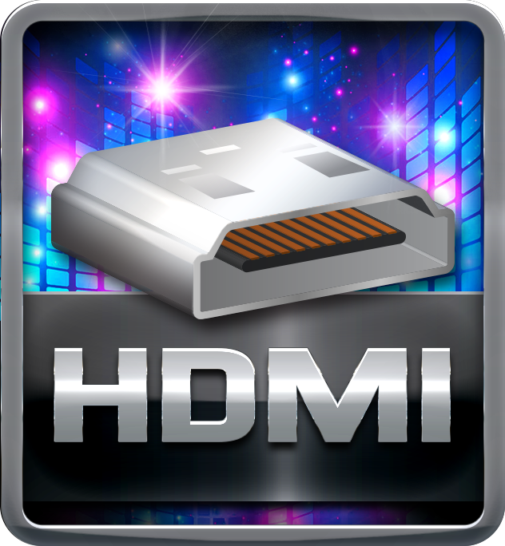
DVI  DVI is better than VGA for LCD displays since it is digital while VGA is analog. For LCD displays, the picture is digitized pixel per pixel. Through DVI, the panel gets data for each pixel, so the picture generated in the Graphics device matches the pixels on the panel itself. | 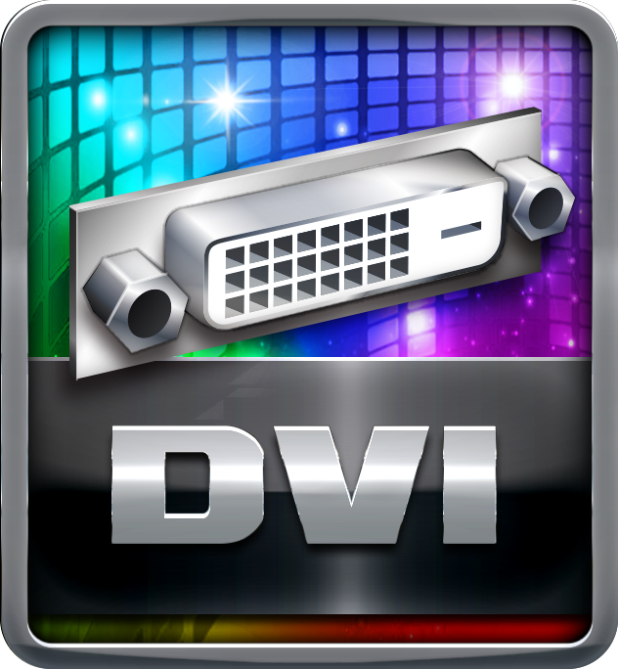
DX12  DirectX 12 introduces the next version of Direct3D, the graphics API at the heart of DirectX. Direct3D is one of the most critical pieces of a game or game engine, and we've redesigned it to be faster and more efficient than ever before. Direct3D 12 enables richer scenes, more objects, and full utilization of modern GPU hardware. | 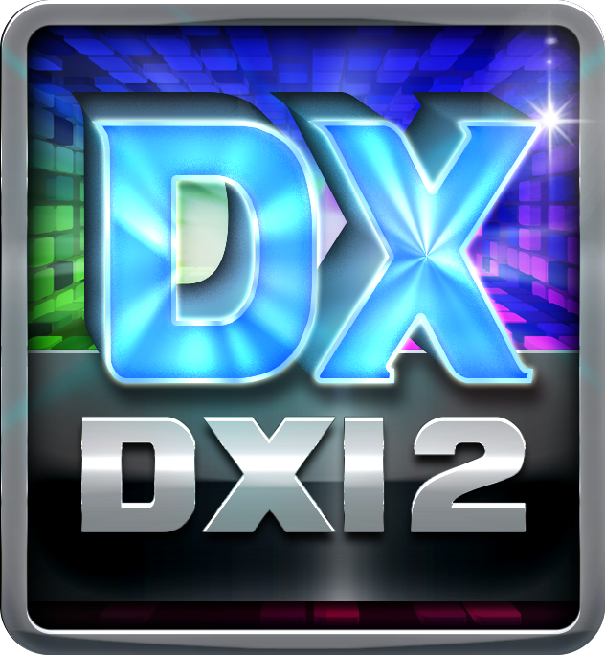
ATI CrossFire X™ Technology

ATI CrossFireX™ is the ultimate multi-GPU performance gaming platform. With game-dominating power, ATI CrossFireX technology enables two or more discrete graphics processors to work together to improve system performance. It supports up to four ATI Radeon™ HD graphics cards, making it the most scalable gaming platform ever!

Speed+

Intel GbE LAN  Unlike ordinary LAN solution, Intel® GbE LAN offers fewer CPU resource consumption and more bandwidth stability. Thus, Intel® LAN is the best choice for performance seekers. | 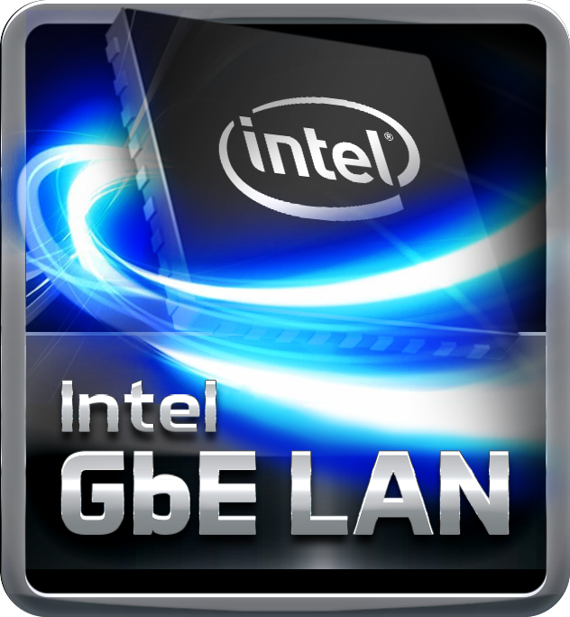
USB 3.1 Gen 1 Type-A

Experience Fastest data transfers at 5 Gbps with USB 3.1 Gen 1--the new latest connectivity standard. Built to connect easily with next-generation components and peripherals, USB 3.1 Gen 1 transfers data 10X faster and backward compatible with previous USB 2.0 components.
USB 3.1 Gen 1 Type-C  USB 3.1 Gen 1 Type-C supports up to 5Gbps data transfer speed. Moreover, it features fool-proof and reversible design more convenient to use. | 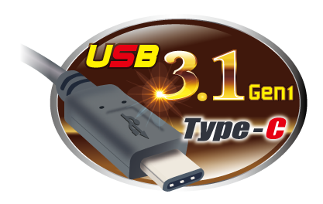
USB 3.1 Gen 2 Type-A

USB 3.1 Gen 2 is a new standard known as SuperSpeed+, in order to highlight the improvement from USB3.1 Gen 1(SuperSpeed) transmission speed. The new standard doubles data transfer rate from 5Gbps to 10Gbps. It is also backward compatible with existing USB3.0 connectors and all the USB 2.0 devices.
PCIe M.2  PCIe M.2 32Gb/s delivers the highest bandwidth and lower latency. It is 3 times faster compared with PCIe M.2 10Gb/s. | 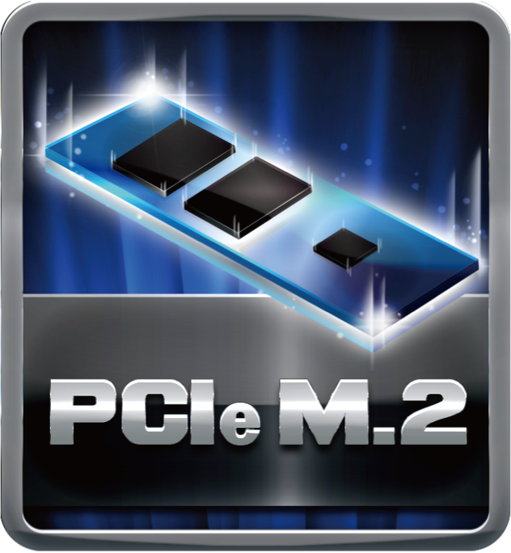
PCIe 3.0  PCIe 3.0 is the ubiquitous and general-purpose PCI Express I/O standard. At 8GT/s bit rate, the interconnect performance bandwidth is doubled over PCIe 2.0, while preserving compatibility with software and mechanical interfaces. | 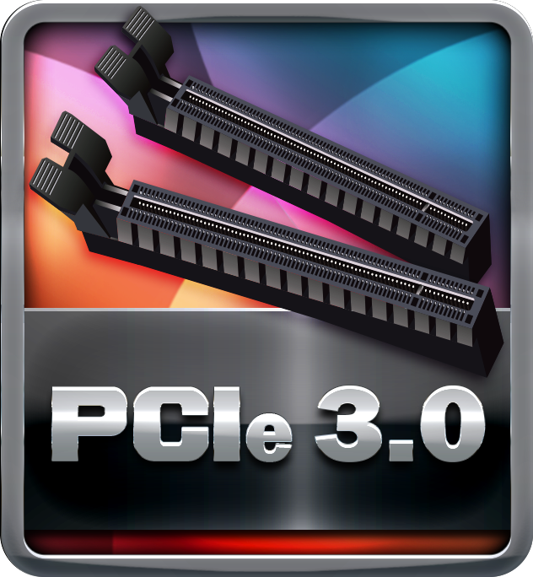

Durable+

Super Durable Ferrite Choke

Super Durable Ferrite Choke brings the benefits of higher current capacity, lower energy loss and better power stability.
Super Durable Solid Caps

The best quality solid state capacitors with ultra low ESR design, the Super Durable Solid Caps doubles the lifespan.
Moistureproof of PCB

The popularity of PC usage and working environment is getting deteriorating and moist (rural, coastal, etc.). The PCB will be oxidizing easily by damp or absorbed moisture, and ionic migration or CAF (Conductive Anodic Filament) will be generated. Moisture-proof PCB meets high density and high reliability requirements for moisture proof.
Low RdsOn P-Pak MOS

Low resistance design can significantly reduce the current out of energy loss.
Low temperature, small size, excellent thermal conductivity.
100% Solid Caps

With armor-plated Biostar Technology, all capacitors are placed with 100% solid capacitors that have a lasting life cycle, durability and stability for crucial components.

Protection+

VIVID LED ARMOR  The new VIVID LED Armor comes with I/O Armor and Audio Armor to protect the I/O interfaces and audio electronic components from static electricity. What’s better, it exclusively features the onboard RGB full-color LED lightings with BIOSTAR VIVID LED DJ application for DIY lovers to create their unique personal styles by changing PC color schemes. | 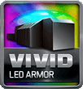
M.2 Cooling Protection  M.2 heatsink features ultra-high cooling efficiency for protecting the M.2 SSD from thermal problems, extending the M.2 SSD lifespan for long-term usage and stable operation. To top it off, this cooling design makes the performance of certain M.2 (PCI-e 3.0x4) products most efficient even under high-temperature operating. | 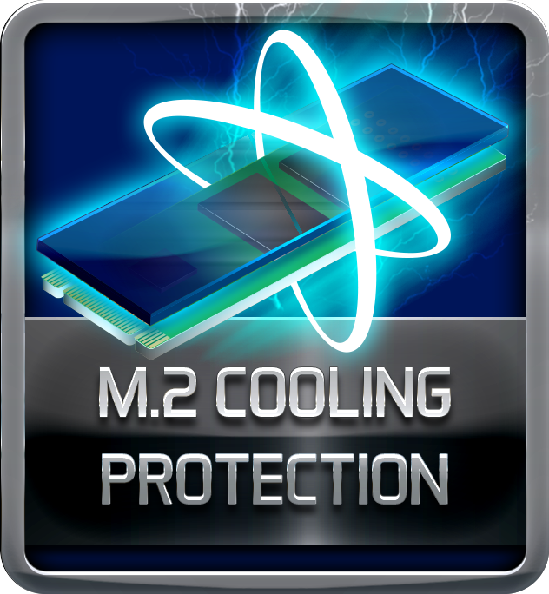
Dual BIOS

Dual BIOS technology offers a backup BIOS chip to take over the failed main BIOS and recover the system automatically without factory repair.
Super Anti-Surge Protection

BIOSTAR exclusive Anti-Surge design provides the best protection of board and extends the product life. Having the latest model of "Transient Voltage Suppressor" on- board can effectively protect the board circuit, reducing the shocks caused by ESD as well as other damages arising from overvoltage transients to enhance system durability.
Super LAN Surge Protection  Super LAN Surge Protection, providing LAN port with more advanced antistatic protection capabilities by adding an integrated chip to strengthen electrical stability and prevent damage from lightning strikes and electrical surges. SLSP (Super LAN Surge Protection) series motherboard upgrades the existing system protection standards with maximum 4X protection comparing to other board makers. | 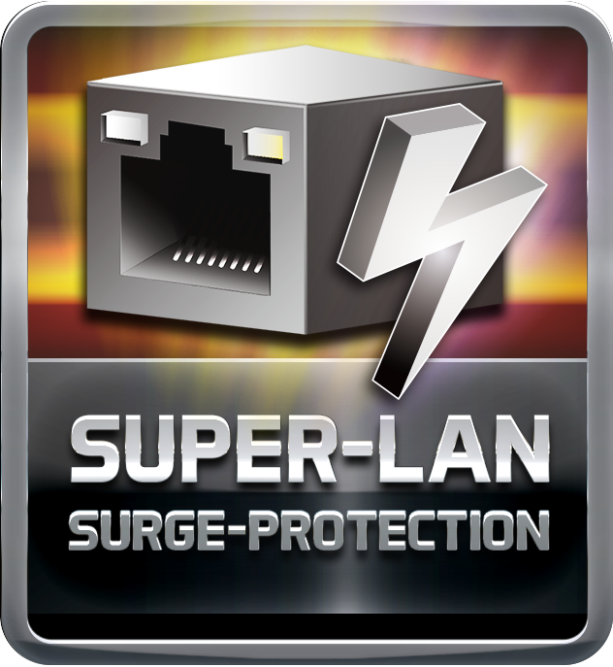
ESD Protection  ESD (Electrostatic Discharge) is the major factor to destroy the PC by electrical overstress (EOS) condition. ESD occurred by PC users when touch any devices connect to a PC, which may result in damage to the motherboard or parts. ESD protection is designed to protect the motherboard and equipment from damage by EOS. | 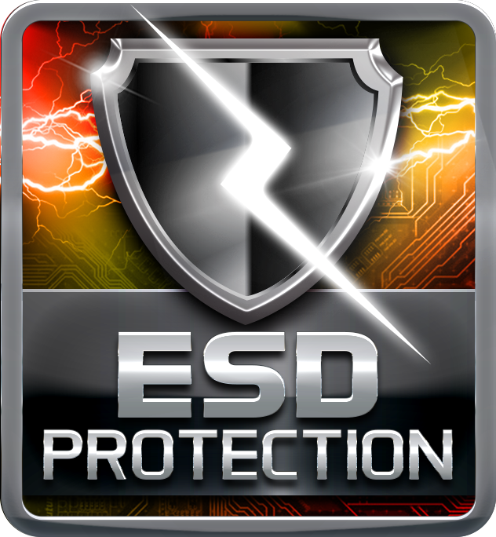
USB Polyswitch

On board dedicated power fuse to help prevent USB port failure. It prevents USB Port overcurrent and safe guard your system and device lifespan.
BIOS Virus Protection

When enabled, the BIOS will protect the boot sector and partition table by halting the system and flashing a warning message whether there's an attempt to write to these areas.
OC / OV / OH Protection

OC / OV / OH Protection design detects overvoltage conditions and prevents voltage surges from spreading in real time. It also actively cuts off the overvoltage supply to protect your system.

DIY+

VIVID LED DJ  New VIVID LED DJ with more customizability and options to control multiple RGB LED lighting zones independently. Users can control color, speed and brightness for different modes at ease. Moreover,have more possibilities for users to create unlimited creativity with 5050 LED FUN ZONE which comes with dual RGB LED products. | 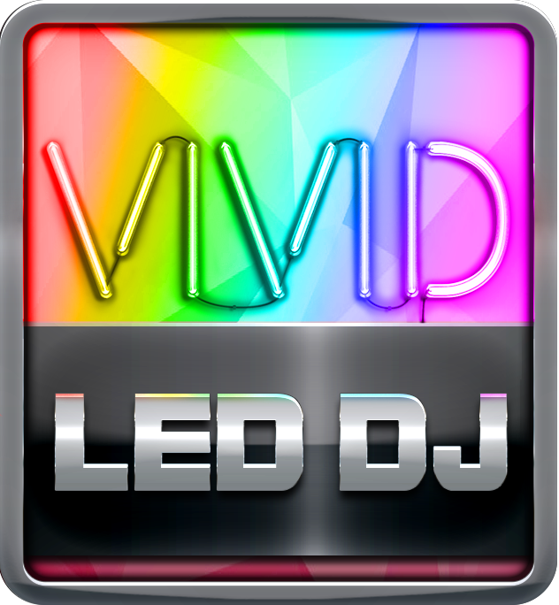
5050 LED Fun ZONE

The brand-new 5050 LED FUN ZONE comes with two 5050 LED headers to bring more colorful lighting options to DIY lovers. They can fully enjoy the DIY fun of modding their PCs with uniquely personal style and LED strip or any kind of LED product to adjust the color of LED and change system color scheme by VIVID LED DJ application. Vivid LED DJ fun, Vivid LED lighting style!
GT TOUCH

GT Touch features exclusive Sport and ECO Mode. Under Sport mode, the system boosts the performance automatically. Under ECO mode, the system optimizes energy consumption. Besides, users could define onboard LED configuration for ECO and Sport Mode respectively via Vivid LED DJ.
UEFI BIOS

Unified Extensible Firmware Interface (UEFI) is a brand new framework that provides a revolutionary interface. It is a modern clear and easy-to-use graphical user interface. The UEFI comes with a colorful easy-understand icons leads users into the setup layer directly.
Header Zone

Users can easily assemble their own computer, a simple-swap data discs and other accessories.
Super Rapid Debug 3

Super Rapid Debug 3 posts critical POST code information on a vivid digital LED display.
Super Durable Box Header

Super Durable Box Header provides solid, secure and durable connections between motherboard and peripheral cables.
LN2 Switch  With LN2 mode activated the BIOSTAR motherboard is optimization to remedy the cold boot bug during POST at an extremely low temperature and help the system boot successfully. | 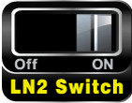
A.I FAN  With A.I FAN users can ensure that their gaming PC can maintain its performance while staying cool. According to different cooling needs and usage scenarios, users can control speed modes. Allows users to have more customizability of fan modes and automatically detects different temperatures to make fan operate at defined speed for optimal cooling performance. Furthermore, A.I FAN support both PWM and DC voltage fans for more cooling options. | 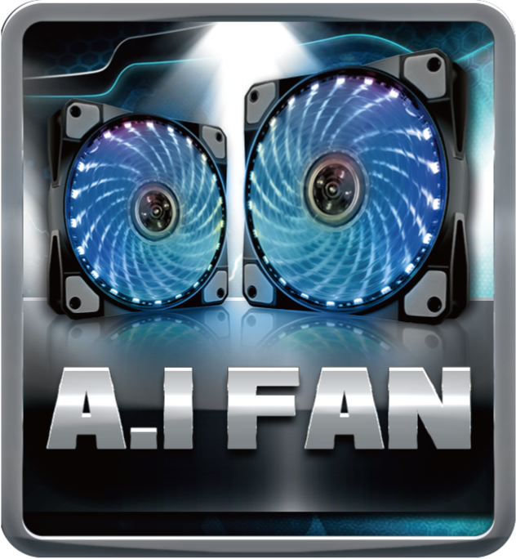
HDMI

The terms HDMI and HDMI High-Definition Multimedia Interface, and the HDMI Logo are trademarks or registered trademarks of HDMI Licensing Administrator, Inc. in the United States and other countries.

