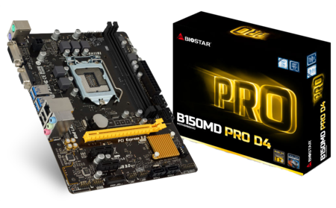 | B150MD PRO D4 6.x  - Supports 6th Generation Intel® Core™ Processor  - Intel B150 single chip architecture  - Support 2-DIMM DDR4-2133/ 1866 up to 32G maximum capacity  - Support USB 3.0  - Support DVI display port  - Support GbE LAN

Chipset | - Intel B150
CPU SUPPORT | - 7th & 6th Gen Intel® Core™ i7 LGA 1151 Processor  - 7th & 6th Gen Intel® Core™ i5 LGA 1151 Processor  - 7th & 6th Gen Intel® Core™ i3 LGA 1151 Processor  - 7th & 6th Gen Intel® Pentium® LGA 1151 Processor  - 7th & 6th Gen Intel® Celeron® LGA 1151 Processor  - Maximum CPU TDP (Thermal Design Power) : 91Watt
MEMORY | - Support Dual Channel DDR4 2133/ 1866 MHz  - 2 x DDR4 DIMM Memory Slot  - Max. Supports up to 32GB Memory
INTEGRATED VIDEO | - By CPU model  - Supports DX12  - Supports HDCP
STORAGE | - 6 x SATA III Connector
LAN | - Realtek RTL8111H - 10/100/1000Mb/s Controller  - Support Super LAN Surge Protection
AUDIO CODEC | - Realtek ALC887 8-Channel HD Audio
USB | - 4 x USB 3.0 Port  - 1 x USB 3.0 Header  - 2 x USB 2.0 Port  - 2 x USB 2.0 Header
EXPANSION SLOT | - 1 x PCI-E 3.0 x16 Slot  - 2 x PCI-E 3.0 x1 Slot
REAR I/O | - 1 x PS/2 Mouse  - 1 x PS/2 Keyboard  - 4 x USB 3.0 Port  - 2 x USB 2.0 Port  - 1 x DVI-D Connector, resolution up to 1920 x 1200 @60Hz  - 1 x VGA Port, resolution up to 1920 x 1200 @60Hz  - 1 x LAN Port  - 3 x Audio Jacks
INTERNAL I/O | - 1 x USB 3.0 Header  - 2 x USB 2.0 Header  - 6 x SATA III Connector (6Gb/s)  - 1 x Front Audio Header  - 1 x Front Panel Header  - 1 x CPU Fan Connector  - 1 x System Fan Connector  - 1 x COM Port Header
H/W MONITORING | - CPU / System Temperature Monitoring  - CPU / System Fan Monitoring  - Smart / Manual CPU Fan Control  - System Voltage Monitoring
DIMENSION | - Micro ATX Form Factor Dimension: 22.6cm x 17.4cm ( W x L )
OS SUPPORT | - Supports Windows 7 / 8.1(x64) / 10(x64)
BUNDLE SOFTWARE | - BullGuard  - BIO-Remote2  - Smart Speed LAN
ACCESSORIES | - 2 x SATA Cable  - 1 x I/O Shield  - 1 x DVD Driver  - 1 x Quick Guide
FEATURES | - Supports 100% Solid capacitor  - Supports Charger Booster  - Supports BIOS Online Update

CPU-Chipset

Intel B150 chipset  The Intel® B150 chipset is a single-chipset design to support socket 1151 Intel® 6th generation Intel® Core™ processor-based platform. Provides excellent performance and increased bandwidth and stability. Intel® B150 chipset can also enable iGPU function, letting users enjoy the latest Intel® integrated graphic performance. The PC platform features improved adaptive performance that adds speed when you need it. When combined with advanced system responsiveness, the platform delivers the ultimate PC experience. | 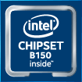

Audio+

HD Audio

Provides high quality sound with minimal loss of audio fidelity.
AudioArt Capacitors

PRO series comes with Nichicon high-end audio capacitors. Nichicon Capacitors offer artistic-like sound resolution and Hi-Fi audio amplification effect, making your room a live concert.

Video+

DVI  DVI is better than VGA for LCD displays since it is digital while VGA is analog. For LCD displays, the picture is digitized pixel per pixel. Through DVI, the panel gets data for each pixel, so the picture generated in the Graphics device matches the pixels on the panel itself. | 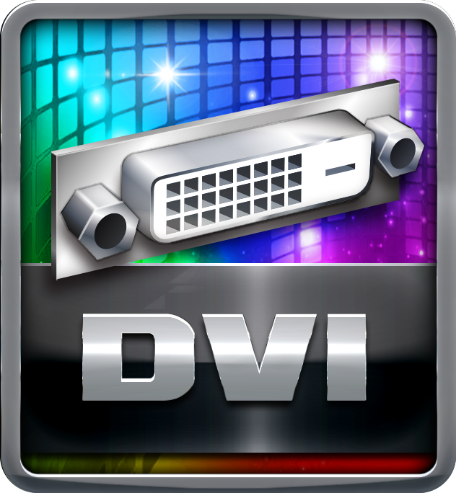
DX12  DirectX 12 introduces the next version of Direct3D, the graphics API at the heart of DirectX. Direct3D is one of the most critical pieces of a game or game engine, and we've redesigned it to be faster and more efficient than ever before. Direct3D 12 enables richer scenes, more objects, and full utilization of modern GPU hardware. | 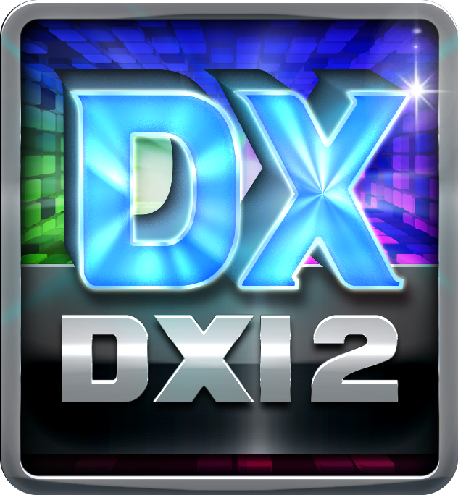

Speed+

USB 3.0

Experience Fastest data transfers at 5 Gbps with USB 3.0--the new latest connectivity standard. Built to connect easily with next-generation components and peripherals, USB 3.0 transfers data 10X faster and backward compatible with previous USB 2.0 components.
PCIe 3.0  PCIe 3.0 is the ubiquitous and general-purpose PCI Express I/O standard. At 8GT/s bit rate, the interconnect performance bandwidth is doubled over PCIe 2.0, while preserving compatibility with software and mechanical interfaces. | 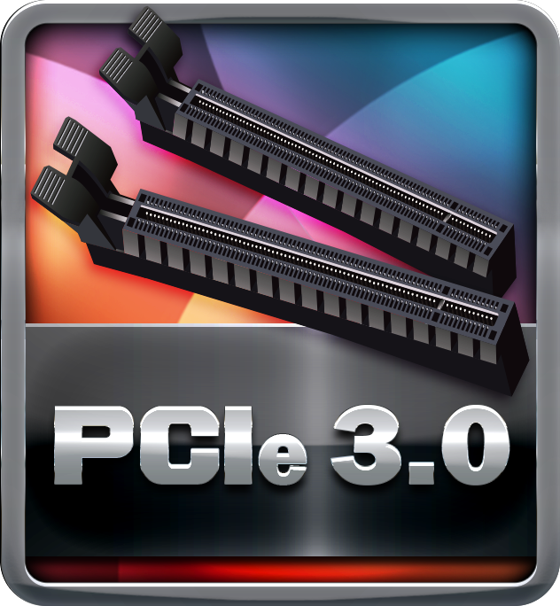
SATAIII 6Gbps  SATAIII 6Gbps provides a higher bandwidth to retrieve and transfer HD media. With this super speed data transfer, SATAIII allows an incredible data boost which is 2x faster than the SATA II. | 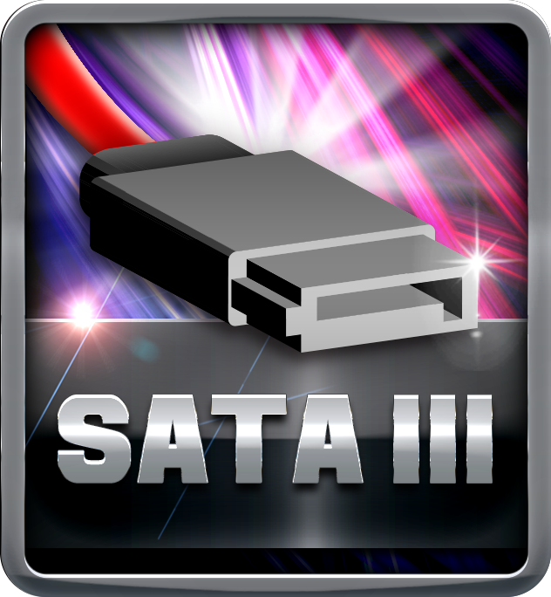

Durable+

Low RdsOn P-Pak MOS

Low resistance design can significantly reduce the current out of energy loss.
Low temperature, small size, excellent thermal conductivity.
Tough Power Enhanced

To ensure the longevity of motherboard, PRO series with Tough Power Enhanced can endure massive electric current and ensure full energy output without additional energy loss, just like a super man protecting your PC system.

Protection+

Super Anti-Surge Protection

BIOSTAR exclusive Anti-Surge design provides the best protection of board and extends the product life. Having the latest model of "Transient Voltage Suppressor" on- board can effectively protect the board circuit, reducing the shocks caused by ESD as well as other damages arising from overvoltage transients to enhance system durability.
Super LAN Surge Protection  Super LAN Surge Protection, providing LAN port with more advanced antistatic protection capabilities by adding an integrated chip to strengthen electrical stability and prevent damage from lightning strikes and electrical surges. SLSP (Super LAN Surge Protection) series motherboard upgrades the existing system protection standards with maximum 4X protection comparing to other board makers. | 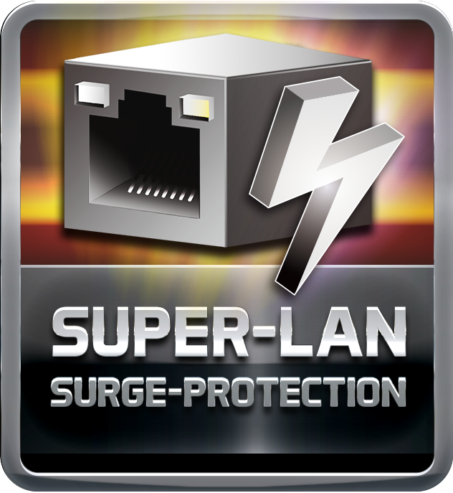
ESD Protection  ESD (Electrostatic Discharge) is the major factor to destroy the PC by electrical overstress (EOS) condition. ESD occurred by PC users when touch any devices connect to a PC, which may result in damage to the motherboard or parts. ESD protection is designed to protect the motherboard and equipment from damage by EOS. | 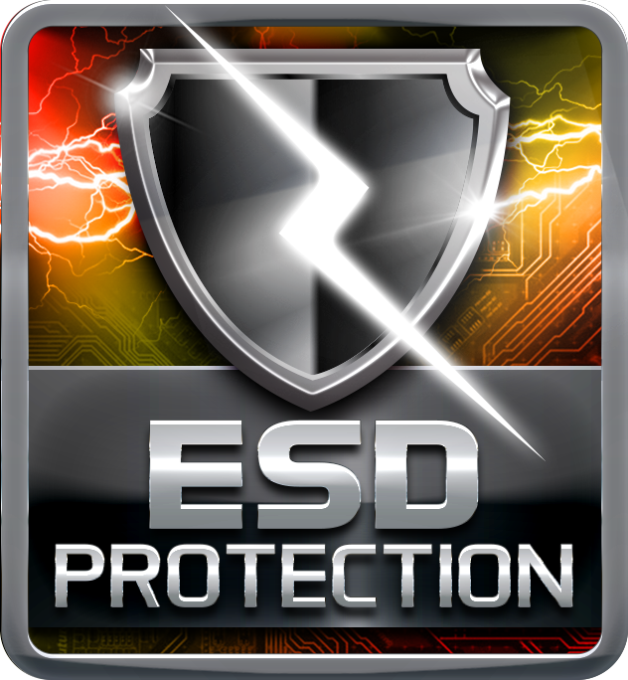
USB Polyswitch

On board dedicated power fuse to help prevent USB port failure. It prevents USB Port overcurrent and safe guard your system and device lifespan.
OC / OV / OH Protection

OC / OV / OH Protection design detects overvoltage conditions and prevents voltage surges from spreading in real time. It also actively cuts off the overvoltage supply to protect your system.

DIY+

UEFI BIOS

Unified Extensible Firmware Interface (UEFI) is a brand new framework that provides a revolutionary interface. It is a modern clear and easy-to-use graphical user interface. The UEFI comes with a colorful easy-understand icons leads users into the setup layer directly.
Header Zone

Users can easily assemble their own computer, a simple-swap data discs and other accessories.
BIO-Remote 2

BIO-Remote2 Technology is featuring users a better Home Theater environment. Users who own either Android mobile or Apple goods are able to access and control your PC remotely; At this moment, you’re smart device became a intelligent and functional remote controller; more than that, BIO-Remote2 also includes both function of mouse pad and power point presentation mode.
HDMI

The terms HDMI and HDMI High-Definition Multimedia Interface, and the HDMI Logo are trademarks or registered trademarks of HDMI Licensing Administrator, Inc. in the United States and other countries.

