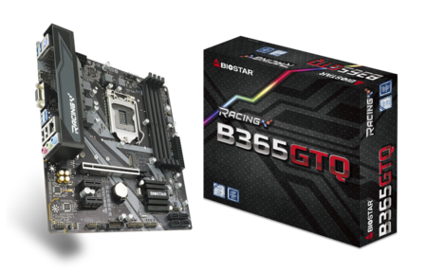 | B365GTQ 5.X  - Supports 9th & 8th Generation Intel® Core™ Processor  - Intel B365 single chip architecture  - Support 4-DIMM DDR4-1866/ 2133/ 2400/ 2666 up to 64GB maximum capacity  - Support PCIe M.2(32Gb/s)  - Support Intel® Optane Technology  - Support USB 3.1 Gen1  - Supports HDMI 4K resolution  - Support GbE LAN

Chipset | - Intel B365
CPU SUPPORT | - Socket 1151 for 9th / 8th Gen Intel® Core, Pentium and Celeron processors  - * 9th / 8th Generation Intel® Core™ Processor Family only support 300-Series  - * Please refer to www.biostar.com.tw for CPU support list
MEMORY | - Supports Dual Channel DDR4 1866/2133/2400/2666  - 4x DDR4 DIMM Memory Slot, Max. Supports up to 64 GB Memory  - Each DIMM supports non-ECC 4/8/16GB DDR4 module  - * Please refer to www.biostar.com.tw for Memory support list
INTEGRATED VIDEO | - By CPU model  - Supports DX12  - Supports HDCP
STORAGE | - 4x SATA III Connector (6Gb/s)  - 1x M.2 (M Key) : Supports PCI-E 3.0 x4 (32Gb/s) & SATA III (6Gb/s) SSD  - Supports PCIe RAID 0, 1, 5, 10 / Intel® Rapid Storage Technology & Intel® Optane Technology
LAN | - RTL8111H  - 10/ 100/ 1000 Mb/s auto negotiation, Half / Full duplex capability  - Supports Super LAN Surge Protection
AUDIO CODEC | - ALC887  - 7.1 Channels, High Definition Audio
USB | - 6x USB 3.1(Gen1) port (4 on rear I/Os and 2 via internal header)  - 6x USB 2.0 port (2 on rear I/Os and 4 via internal header)
EXPANSION SLOT | - 2x PCIe 3.0 x1 Slot  - 1x PCIe 3.0 x16 Slot
REAR I/O | - 1x PS/2 Keyboard Port  - 1x HDMI Port  - 1x VGA Port  - 1x LAN Port  - 2x USB 2.0 Port  - 4x USB 3.1(Gen1) Port  - 3x Audio Jack
INTERNAL I/O | - 4x SATA III Connector (6Gb/s)  - 2x USB 2.0 Header (each header supports 2 USB 2.0 ports)  - 1x USB 3.1(Gen1) Header (each header supports 2 USB 3.1(Gen1) ports)  - 1x 8-Pin Power Connector  - 1x 24-Pin Power Connector  - 1x CPU Fan Connector  - 2x System Fan Connector  - 1x Front Panel Header  - 1x Front Audio Header  - 1x Clear CMOS Header  - 1x COM Port Header  - 2x LED Header (12V/ 5V)
H/W MONITORING | - CPU / System Temperature Monitoring  - CPU / System Fan Monitoring  - Smart / Manual CPU Fan Control  - System Voltage Monitoring
DIMENSION | - Micro ATX Form Factor Dimension: 244mm x 210mm ( W x L )
OS SUPPORT | - Supports Windows 10(64bit) /11(64bit)  - ※Biostar reserves the right to add or remove support for any OS with or without notice.
BUNDLE SOFTWARE | - Racing GT EVO Utility  - BullGuard
ACCESSORIES | - 2 x SATA Cable  - 1 x I/O Shield  - 1 x DVD Driver  - 1 x Quick Guide

CPU-Chipset

Intel B365 chipset  Give your small business a boost with the Intel® B365 Chipset and the 9th Generation Intel® Core™ processor. The Intel B365 chipset provides you with the power and performance you need for your small business, entertainment and digital life. | 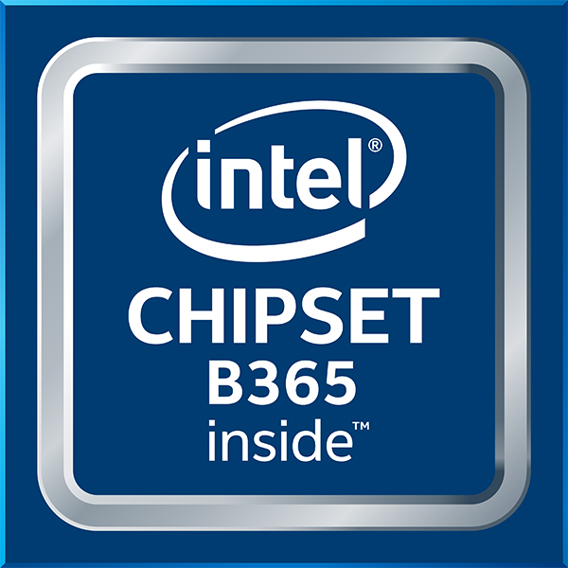

Audio+

Hi-Fi

A combination of exclusive hardware &amp; software design including &quot;ground-isolation circuit design&quot;,&quot;an independent audio power&quot;, and &quot;a built=on-board amplifier&quot;, with all these hardware features gives you the best audio quality and performance. As for software, we offer you a free bundle utility &quot;Multi-Channel Calibration&quot; which normally you'll find in high level sound systems; this feature allows you to auto detect your location; with a user friendly interface, you can easily adjust the volume of every speakers to make a well balanced surround sound. And of course, the built-on-board amplifier always gives you a super powerful sound comparing to other motherboards.
HD Audio

Provides high quality sound with minimal loss of audio fidelity.
Hi-Fi Ground  BIOSTAR Hi-Fi Ground ( Golden Line ) is noise-blocking multi-layer PCB design to isolates analog audio signals from digital sources. Unique PCB layout is ideal for exceptional clarity and high fidelity sound. | 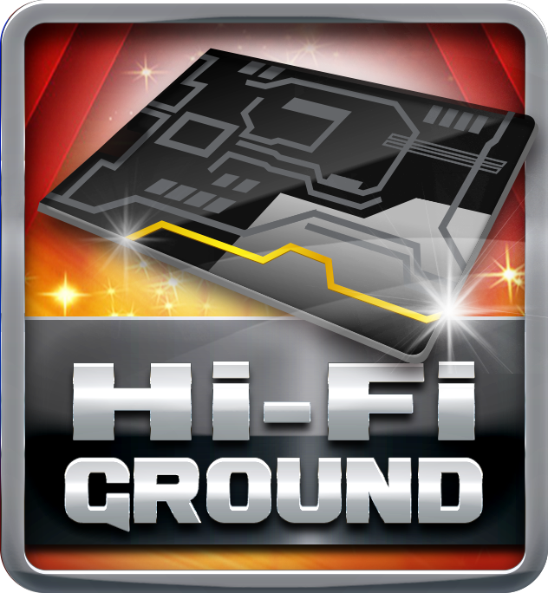
Hi-Fi Sound

BIOSTAR Hi-Fi series motherboards have a sampling rate of 192kHz/24-bit which delivers a high quality audio through an analog connection to your home theater system, multi-channel speakers and high-end headphone. You can enjoy real Blu-ray grade high-definition sound that you’ve never experienced before.
Smart Ear

Smart EAR is a windows-based audio utility which allows you to easily adjust system volume. With its user-friendly GUI, you can also increase or decrease impedance setting (Low/High Gain) to optimize your headphone performance. You can easily enjoy high-quality and awesome sound.
Hi-Fi Cap

BIOSTAR Hi-Fi series motherboards come with high quality ‘Non-Polarized Electrolysis Electric audio capacitors’ for each audio channel circuit. The customized audio capacitors deliver low noise, low distortion, and wide bandwidth to achieve the highest sound resolution and sound expansion. The critical component will ensure the most realistic sound effects to gaming enthusiasts.

Video+

HDMI 4K2K  The new 4K2K resolution enables high-definition image display with four times the resolution of full HD, 4K2K display is faithfully express bright, highly detailed content that fills the entire screen with lifelike images. Connectivity with PCs via a single HDMI cable for displaying 4K2K data. | 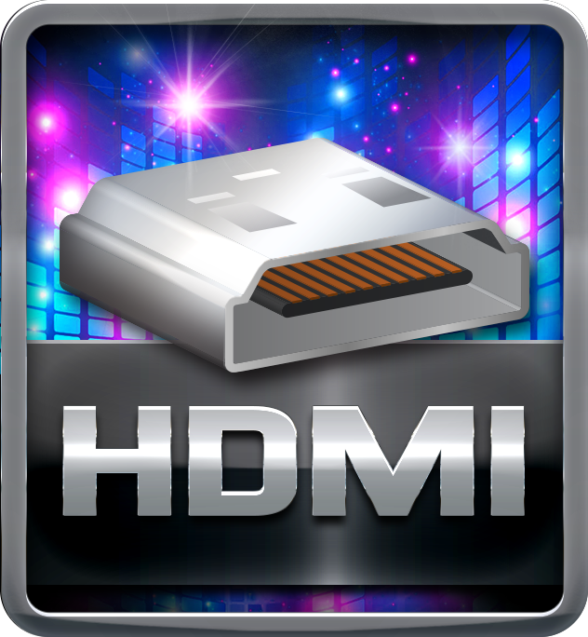
DX12  DirectX 12 introduces the next version of Direct3D, the graphics API at the heart of DirectX. Direct3D is one of the most critical pieces of a game or game engine, and we've redesigned it to be faster and more efficient than ever before. Direct3D 12 enables richer scenes, more objects, and full utilization of modern GPU hardware. | 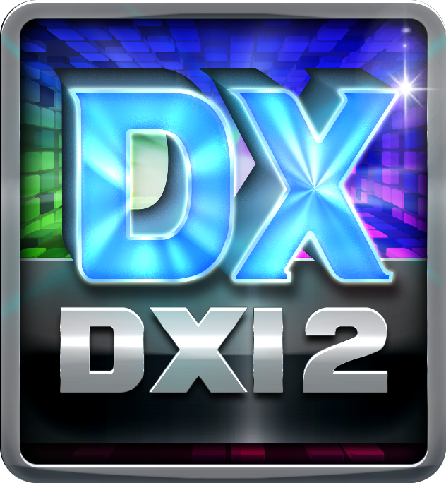
Integrated HDMI with HDCP

Onboard HDMI connector allows full video & audio support. It has industry-leading high definition video quality.

Speed+

USB 3.1 Gen 1 Type-A  Experience Fastest data transfers at 5 Gbps with USB 3.1 Gen 1--the new latest connectivity standard. Built to connect easily with next-generation components and peripherals, USB 3.1 Gen 1 transfers data 10X faster and backward compatible with previous USB 2.0 components. | 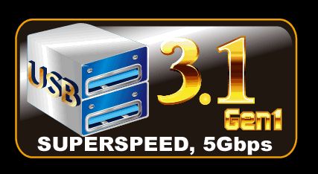
PCIe M.2  PCIe M.2 32Gb/s delivers the highest bandwidth and lower latency. It is 3 times faster compared with PCIe M.2 10Gb/s. | 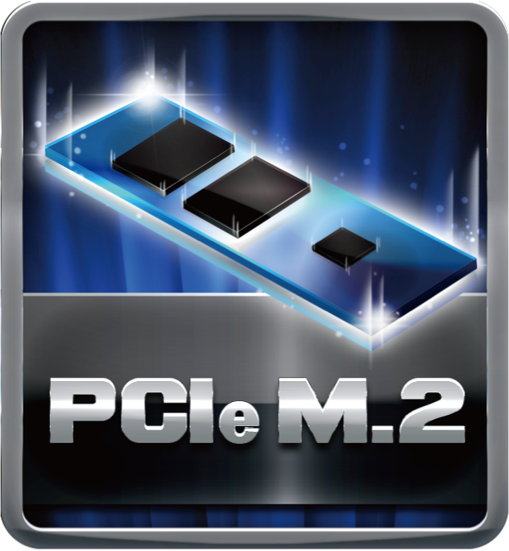
SATAIII 6Gbps  SATAIII 6Gbps provides a higher bandwidth to retrieve and transfer HD media. With this super speed data transfer, SATAIII allows an incredible data boost which is 2x faster than the SATA II. | 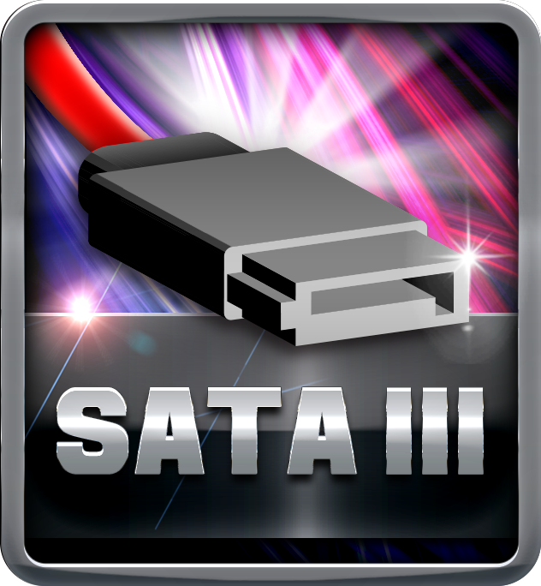
Dual DDR4  The primary advantages of DDR4 over DDR3, include higher module density, lower voltage requirements, coupled with higher data transfer rate. | 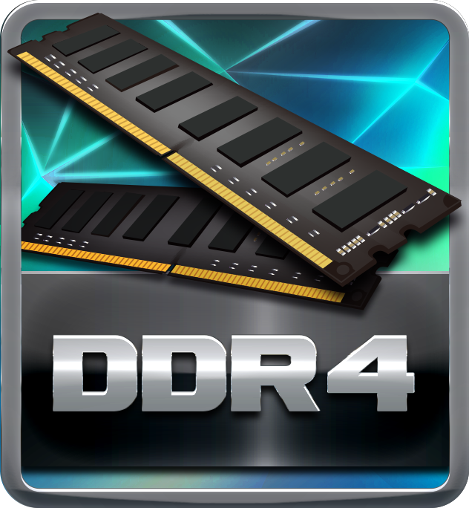

Durable+

Super Durable Ferrite Choke

Super Durable Ferrite Choke brings the benefits of higher current capacity, lower energy loss and better power stability.
Super Durable Solid Caps

The best quality solid state capacitors with ultra low ESR design, the Super Durable Solid Caps doubles the lifespan.
Moistureproof of PCB

The popularity of PC usage and working environment is getting deteriorating and moist (rural, coastal, etc.). The PCB will be oxidizing easily by damp or absorbed moisture, and ionic migration or CAF (Conductive Anodic Filament) will be generated. Moisture-proof PCB meets high density and high reliability requirements for moisture proof.
100% Solid Caps

With armor-plated Biostar Technology, all capacitors are placed with 100% solid capacitors that have a lasting life cycle, durability and stability for crucial components.
Iron Slot Protection  The exclusive Iron Slot Protection can reinforce PCI-E x16 slots to handle heavier graphics cards, prevent bending, and extend longevity of the slot, making the new-gen RACING Series much more robust. | 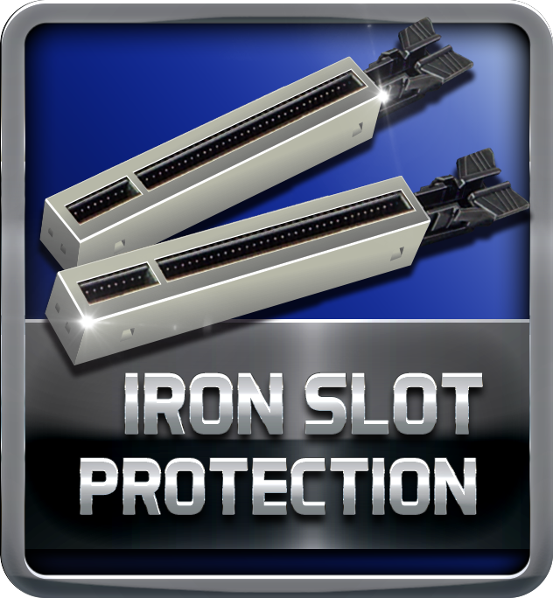

Protection+

Super LAN Surge Protection  Super LAN Surge Protection, providing LAN port with more advanced antistatic protection capabilities by adding an integrated chip to strengthen electrical stability and prevent damage from lightning strikes and electrical surges. SLSP (Super LAN Surge Protection) series motherboard upgrades the existing system protection standards with maximum 4X protection comparing to other board makers. | 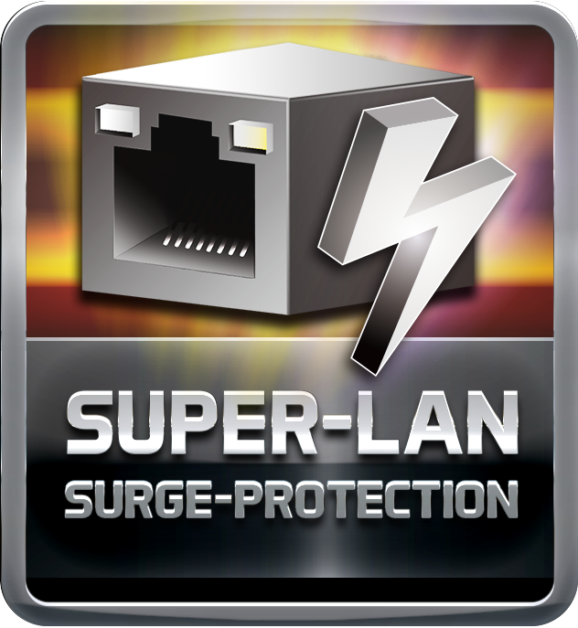
ESD Protection  ESD (Electrostatic Discharge) is the major factor to destroy the PC by electrical overstress (EOS) condition. ESD occurred by PC users when touch any devices connect to a PC, which may result in damage to the motherboard or parts. ESD protection is designed to protect the motherboard and equipment from damage by EOS. | 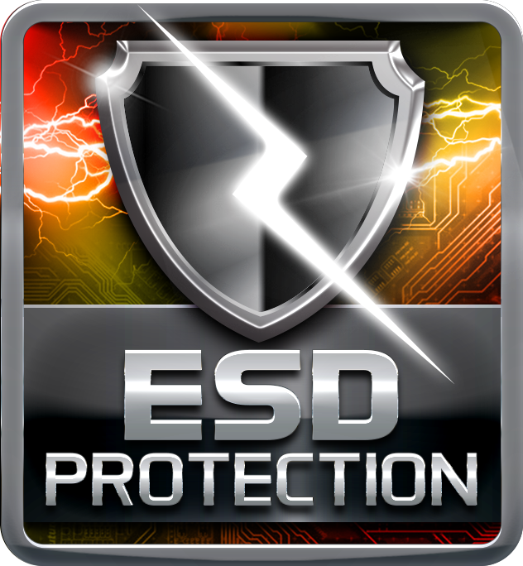
OC / OV / OH Protection

OC / OV / OH Protection design detects overvoltage conditions and prevents voltage surges from spreading in real time. It also actively cuts off the overvoltage supply to protect your system.
BullGuard Internet Security (90 days FREE trial)

BullGuard Internet Security comes with the broadest line-up of internet security features on the market, including: a cutting-edge dual Antivirus engine, Online Backup for your precious files, PC Tune Up to speed up your system, a Game Mode for a seamless gaming experience, Parental Control, Firewall, Safe Browsing and many more. Make the most of your digital life with Bullguard!

DIY+

VIVID LED DJ  New VIVID LED DJ with more customizability and options to control multiple RGB LED lighting zones independently. Users can control color, speed and brightness for different modes at ease. Moreover,have more possibilities for users to create unlimited creativity with 5050 LED FUN ZONE which comes with dual RGB LED products. | 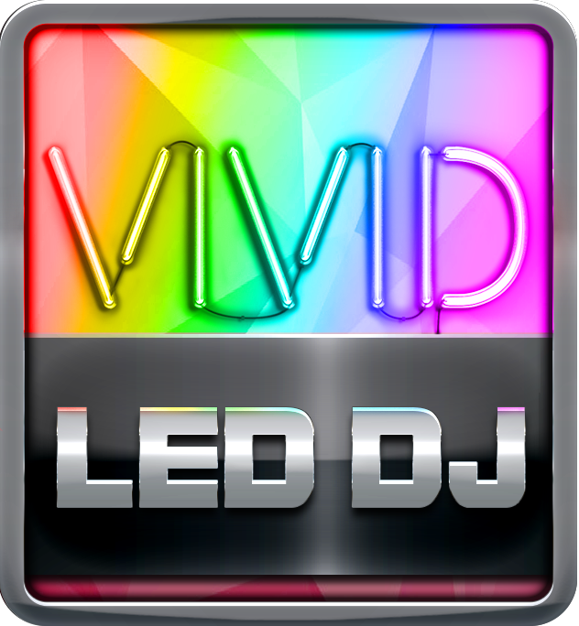
UEFI BIOS

Unified Extensible Firmware Interface (UEFI) is a brand new framework that provides a revolutionary interface. It is a modern clear and easy-to-use graphical user interface. The UEFI comes with a colorful easy-understand icons leads users into the setup layer directly.
A.I FAN  With A.I FAN users can ensure that their gaming PC can maintain its performance while staying cool. According to different cooling needs and usage scenarios, users can control speed modes. Allows users to have more customizability of fan modes and automatically detects different temperatures to make fan operate at defined speed for optimal cooling performance. Furthermore, A.I FAN support both PWM and DC voltage fans for more cooling options. | 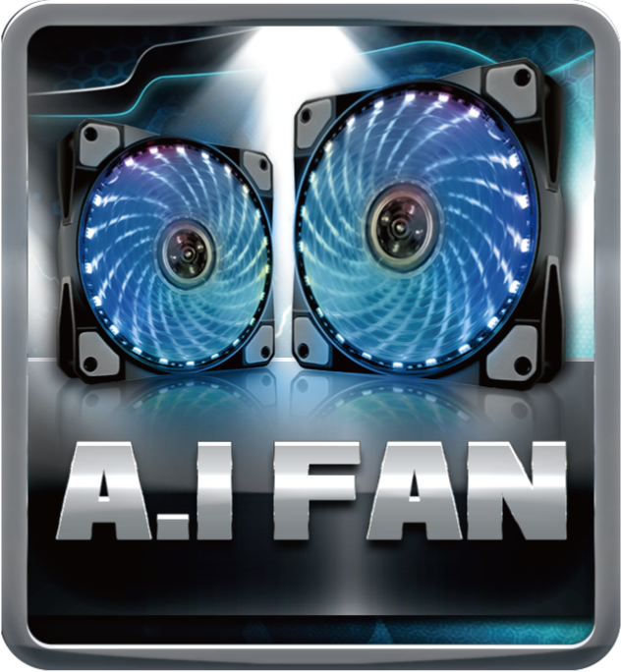
LED ROCK ZONE  LED ROCK ZONE comes with the RGB 12V LED header and Digital 5V LED header which offer more colorful lighting options to DIY lovers. Adjusting the color of LED and changing system colors by VIVID LED DJ will make you fully enjoy the process of PC modding developing your personal style. | 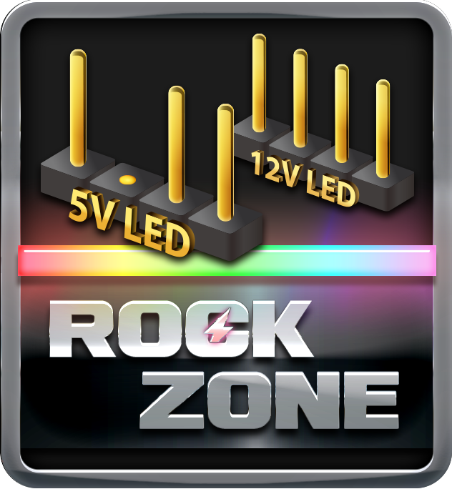
HDMI  The terms HDMI and HDMI High-Definition Multimedia Interface, and the HDMI Logo are trademarks or registered trademarks of HDMI Licensing Administrator, Inc. in the United States and other countries. | 